What it does, what holds it back, and where it can go
Payment, off-catalog sourcing and the speed work are now built and running on the development server. This is what changed, what it measures at, and what is still open.
Abad Naseer. Updated 8 August 2026. Measured on the development server, 25,631 products.

0. What shipped
Chat answers in under a fifth of a second. Money can be taken. Products we do not stock can be ordered.
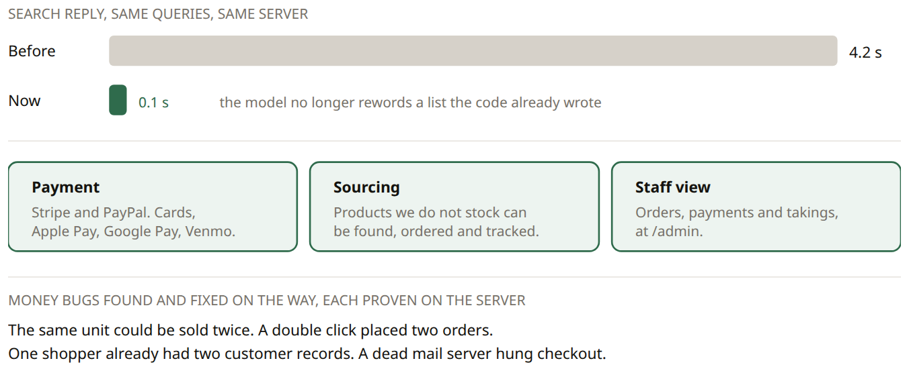
Voice is now about 4 s once the shopper stops speaking. An earlier version of this page said 3.2 s, which came from a three word test clip; watching real use showed recordings were running to a 15 s limit before anything was even sent. That is fixed, and not yet confirmed on a handset.

1. What it does today
Good in the middle, and no longer absent at the end. Still no sign in, so a returning shopper is a stranger.
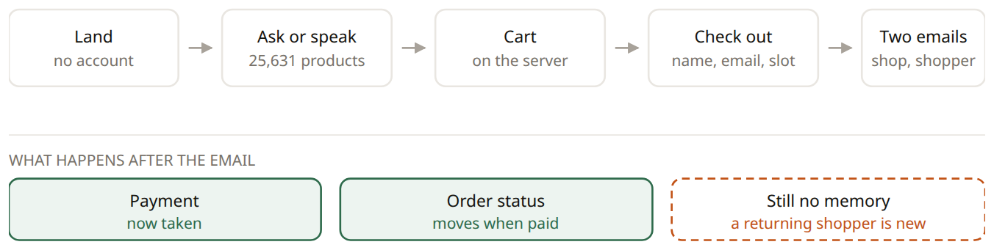
Two of the three gaps are closed. An order is now created unpaid, and only a verified message from the payment provider confirms it and reserves the stock. The footer still advertises "Order Tracking" as a link that goes nowhere.

2. Speed (done)
A search reply is now 0.07 to 0.17 s, measured over three passes. What is left in voice is the time to hear the shopper.
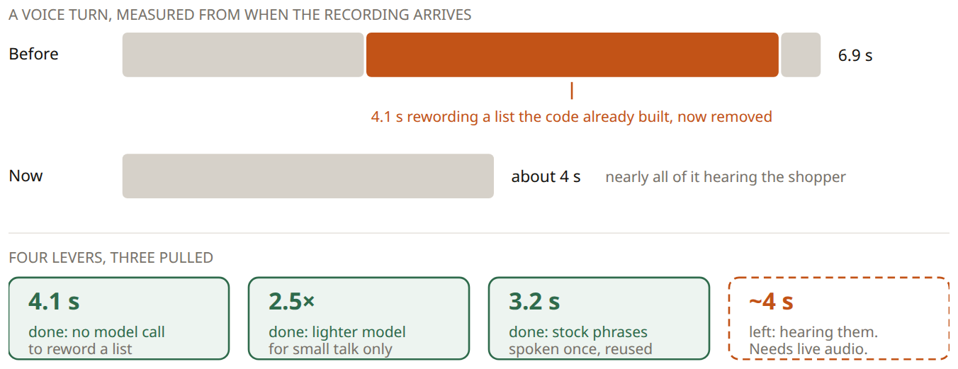
A faster model was tried for hearing the shopper too, and rejected: it saves 440 ms and mishears more often, which is a bad trade when it decides what goes in the basket.

3. Teaching it to sound excited
Writing beats training. And we cannot train yet even if we wanted to.
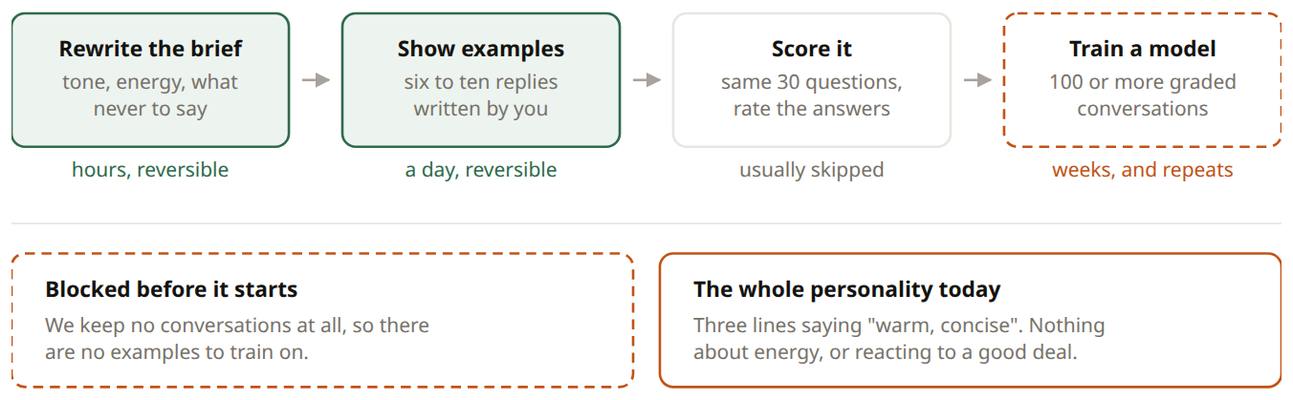
Rewriting those three lines is the cheapest and largest improvement in this document. Start keeping conversations now: it costs almost nothing and is the raw material for scoring, for training, and for section 5.

4. Google integration
Three separate integrations. Sourcing is built. Being found on Google is still blocked by a missing page. The third nobody has mentioned.

A. Selling what we do not stock (built)
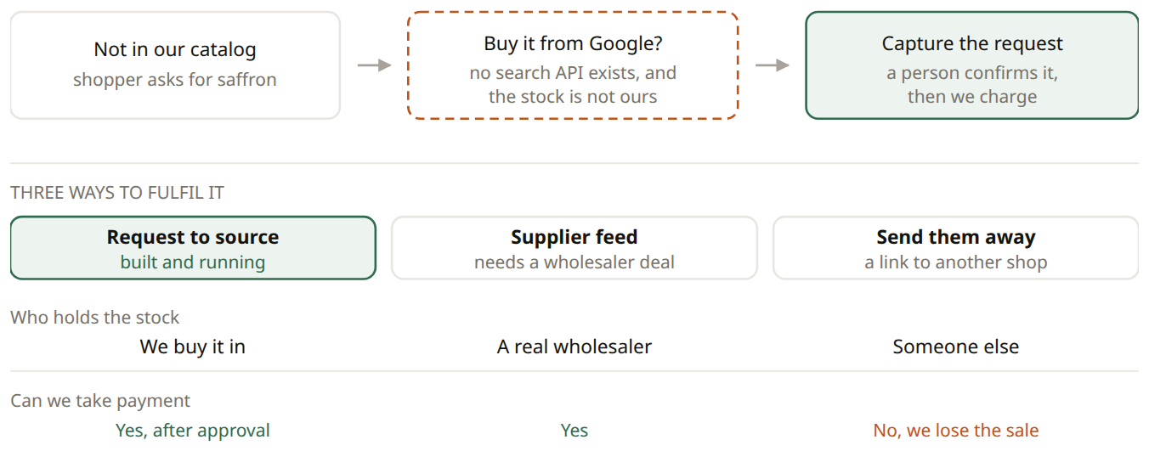
A requested product becomes a real catalog item: it is priced, searchable, orderable and recorded with where it came from, so the list of what shoppers wanted and we did not carry builds itself. Running on sample data by default so no search quota is spent; one setting switches it to live Google results.

B. Being found on Google (still blocked)
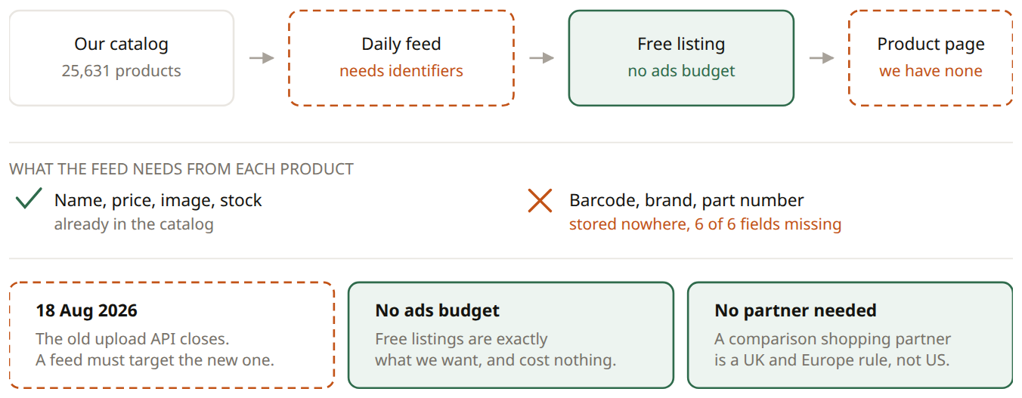
Google requires the product details to sit in the page the server sends, not added afterwards by JavaScript. The site is a static export, so generating a page per product at build time satisfies both needs at once.

C. The integration nobody has mentioned
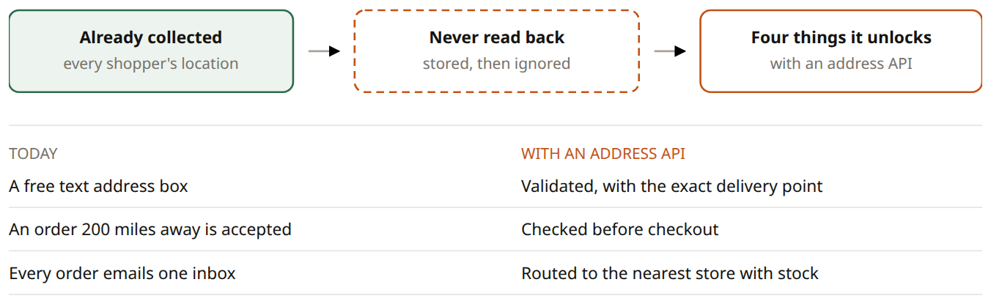
The location is used for exactly one thing today: pasting raw coordinates into the shop's email when the shopper did not type an address.

5. Our own model, or API keys
We already run our own model for the part that matters most, and the part we were buying has just been deleted.
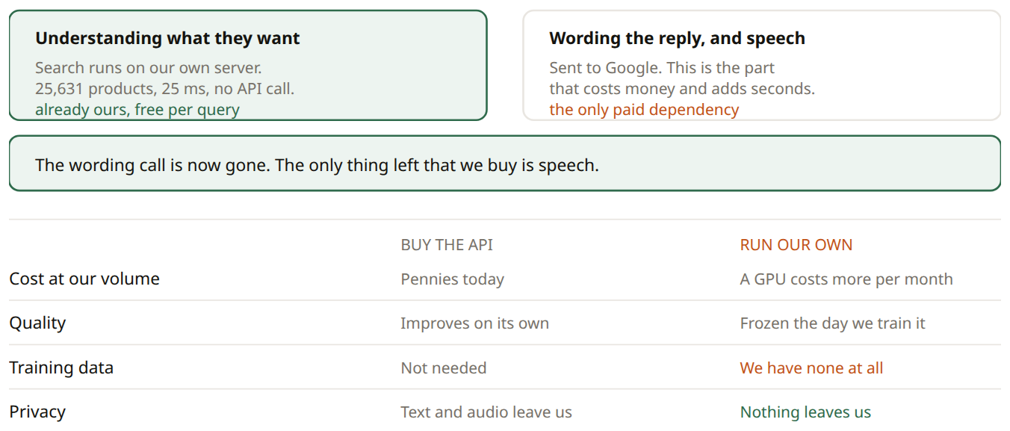
Not yet, and possibly never for wording. We are one change away from not needing a language model to word replies at all, so training one to do that job better would solve a problem we are about to delete. Revisit if speech volume grows, if a customer objects to audio leaving our servers, or if tone genuinely cannot be reached by instruction. Keep the option open by logging conversations now.

6. Capability we already paid for
No new services, no new vendors, no new budget. It is all already in the database.
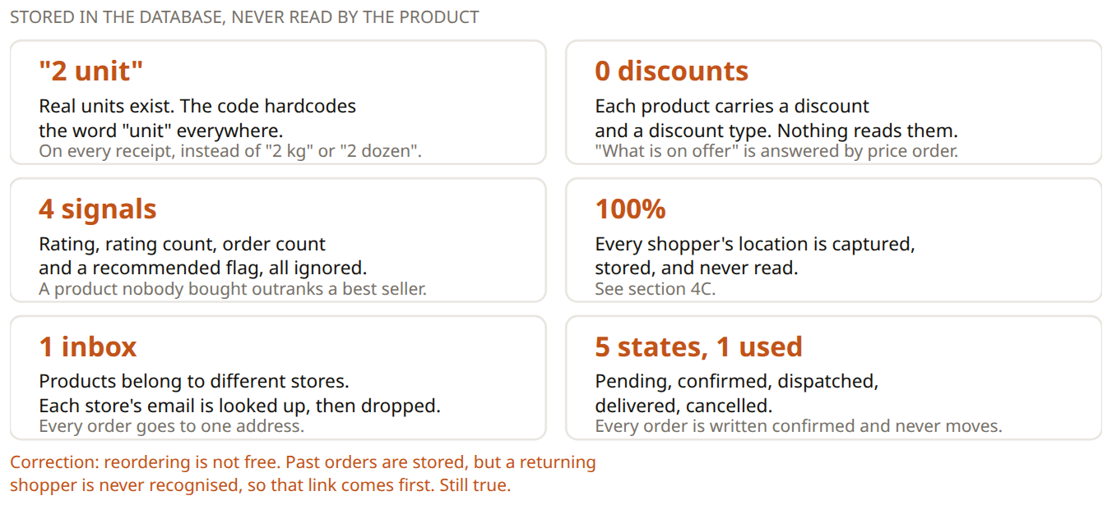
All six are still open. Building on top of this table turned up two more: product ids are not generated by the database at all, and the image column holds thirty characters, which is a filename and not a web address. Both were worked around rather than left to fail quietly.

7. Functional and non functional
What it does, and how well it does it. Green is done since this was written.
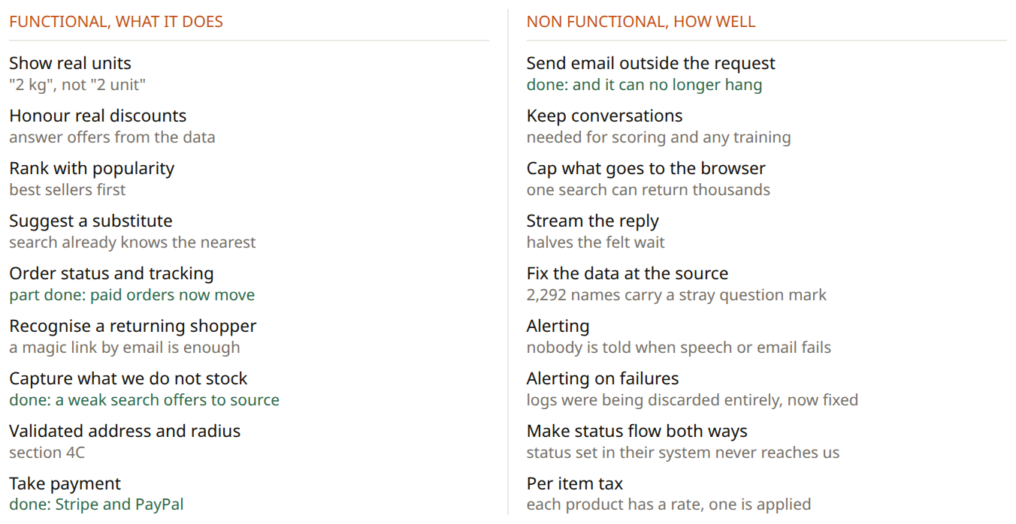

8. How the experience improves
The same shopper, at four points in time. The first has landed.
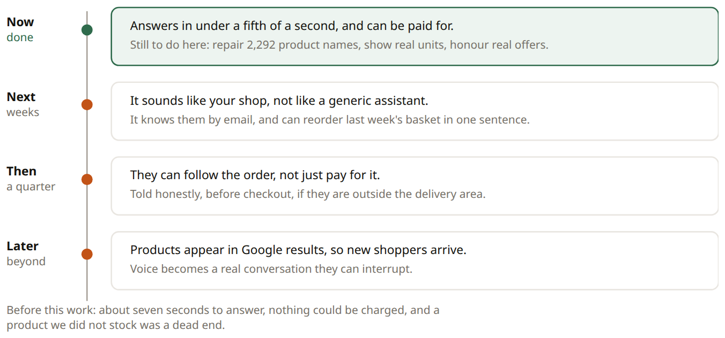

9. Decisions we need
- Do barcodes exist anywhere in the source system? Without them a Google feed needs a brand and part number per product.
- Which country is the business registered in, and when do we swap the test keys for live ones? Stripe and PayPal are both wired up and working on test credentials.
- Who confirms a sourced item, and how do they tell the shopper? The request is captured and the product is in the catalog. The step after that is a person, and we have not defined who.
- Write six to ten replies in the voice you want. Worth more than any model training, and only you can do it.
- May we start keeping conversations? Nothing in section 3 or 5 is possible without them.

