AI-Order | Conversational Shopping Assistant
Payment, Sourcing and Speed
What was built across three phases, how it was done, and the result of every test.
Prepared by: Abad Naseer
Project: AI-Order (SmartMarket) conversational shopping assistant
Environment: Development, dev.agent.fordev.fun
Catalog: 25,631 products
Measured: 8 August 2026

Every screenshot is real output from the development server, produced by re-running each check.

What this covers
Three pieces of work, all built and running on the development server:
- Payment. Taking money with Stripe and PayPal, plus a staff view of orders and takings.
- Products we do not stock. Finding them elsewhere and turning a request into a real catalog item.
- Speed. Making the assistant answer immediately.
Each section says what the problem was, what changed, and how. Every screenshot is real output from the development server. The last section lists each test and its result.
Environment | Development server, dev.agent.fordev.fun
Catalog | 25,631 products
Measured | 8 August 2026
Code | github.com/jafgithub/aichat-v2-abad, branch main

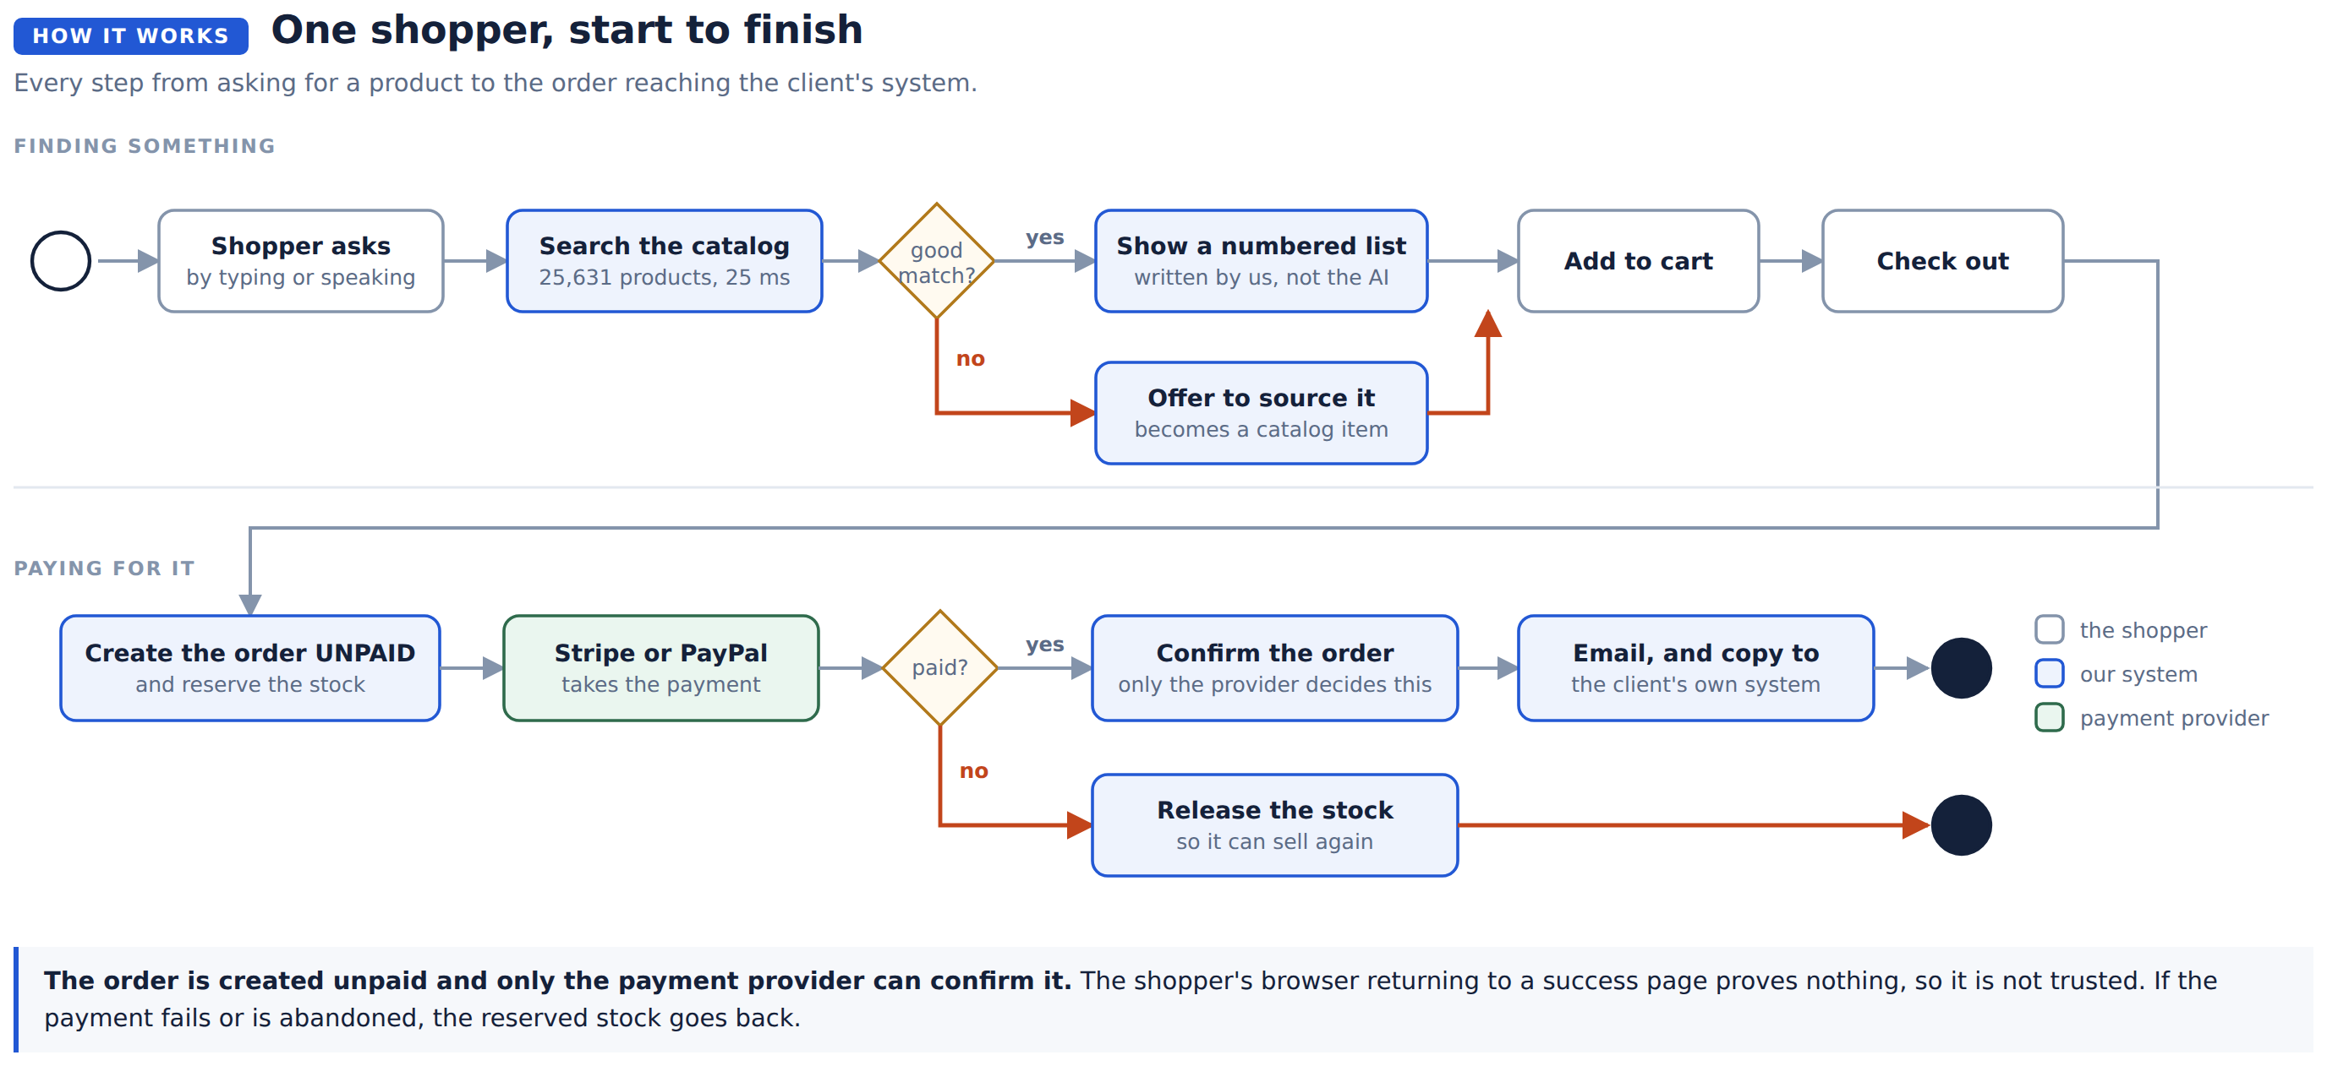
The assistant as a shopper sees it.
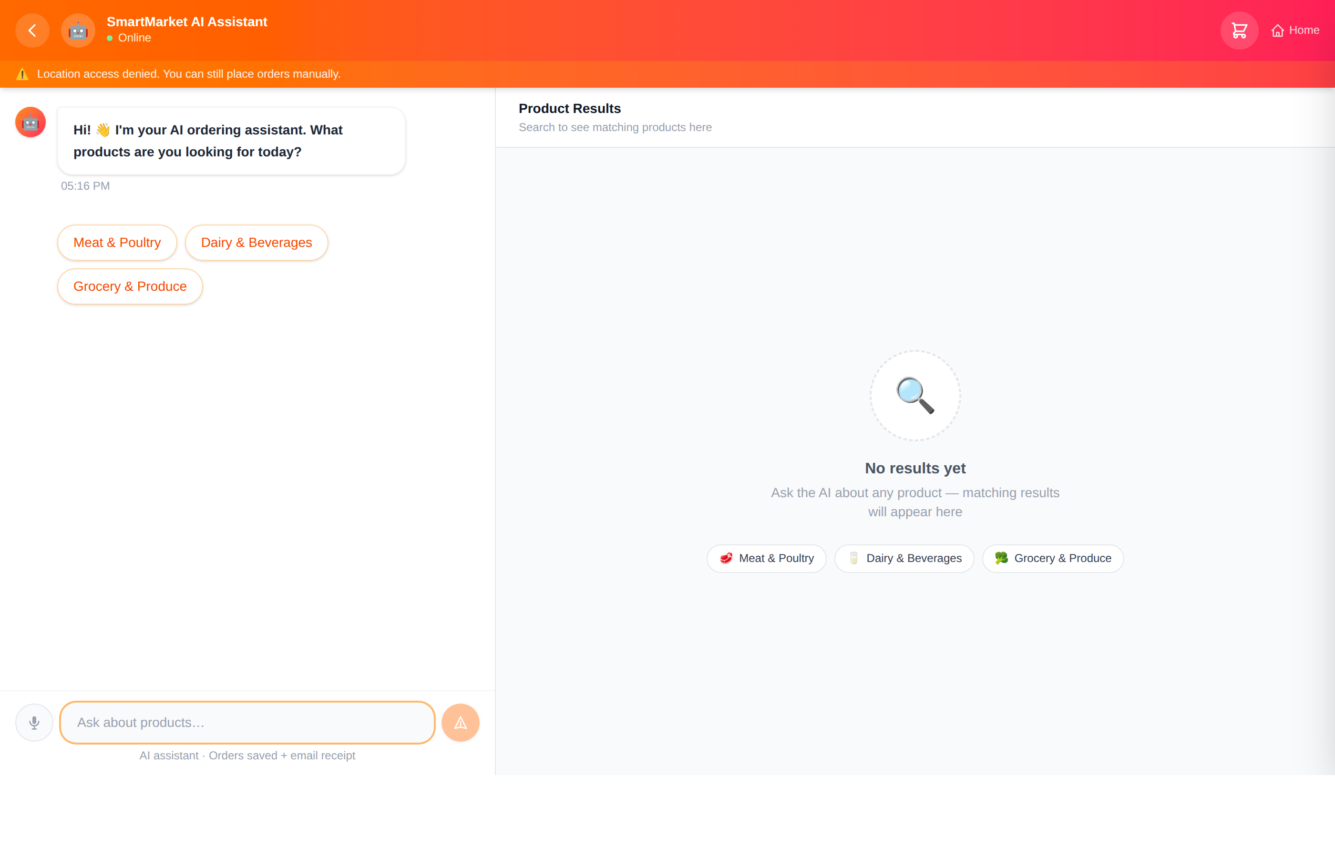

Before and after, at a glance
 | Before | After
Answering a search | 3.8 to 4.7 seconds | 0.07 to 0.26 seconds
Answering by voice | Recording ran to a 15 second limit, then 3 to 21 seconds to understand it | About 4 seconds once the shopper stops speaking
Taking payment | Not possible | Stripe and PayPal
Order status | Always "confirmed", even unpaid | Unpaid until the provider confirms
A product we do not stock | A dead end | Can be requested and ordered
Staff view of orders | None | At /admin
Selling the last unit twice | Possible | Prevented
Double clicking Confirm | Created two orders | Returns the original
Product names | 2,292 showed "Member?s Mark" | 1,919 repaired
Automated tests | 38 | 104

Phase 1. Taking payment

The problem
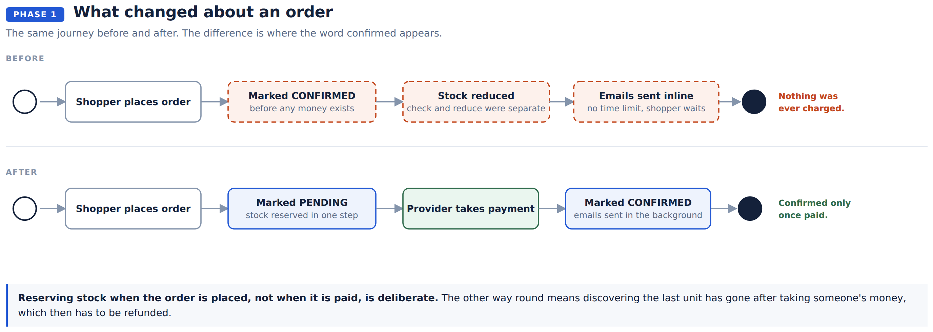
Four faults were found in that same order path while adding payment. They mattered little when nothing was being charged, and a great deal once it was.
Fault | Why it happened
The same unit could be sold twice | Checking the stock and reducing it were separate steps
A double click created two orders | Nothing recognised a repeated request
One shopper had two customer records | Email matching with nothing in the database enforcing it
A stalled mail server hung the checkout | Emails were sent while the shopper waited, with no time limit

Stripe is used through its own hosted payment page, so card details never touch our site. It covers cards, Apple Pay and Google Pay together. PayPal is separate, and brings Venmo.
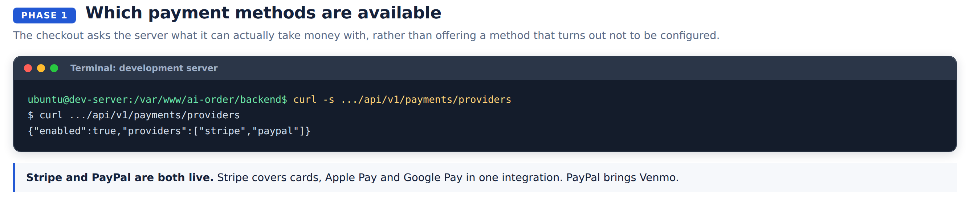
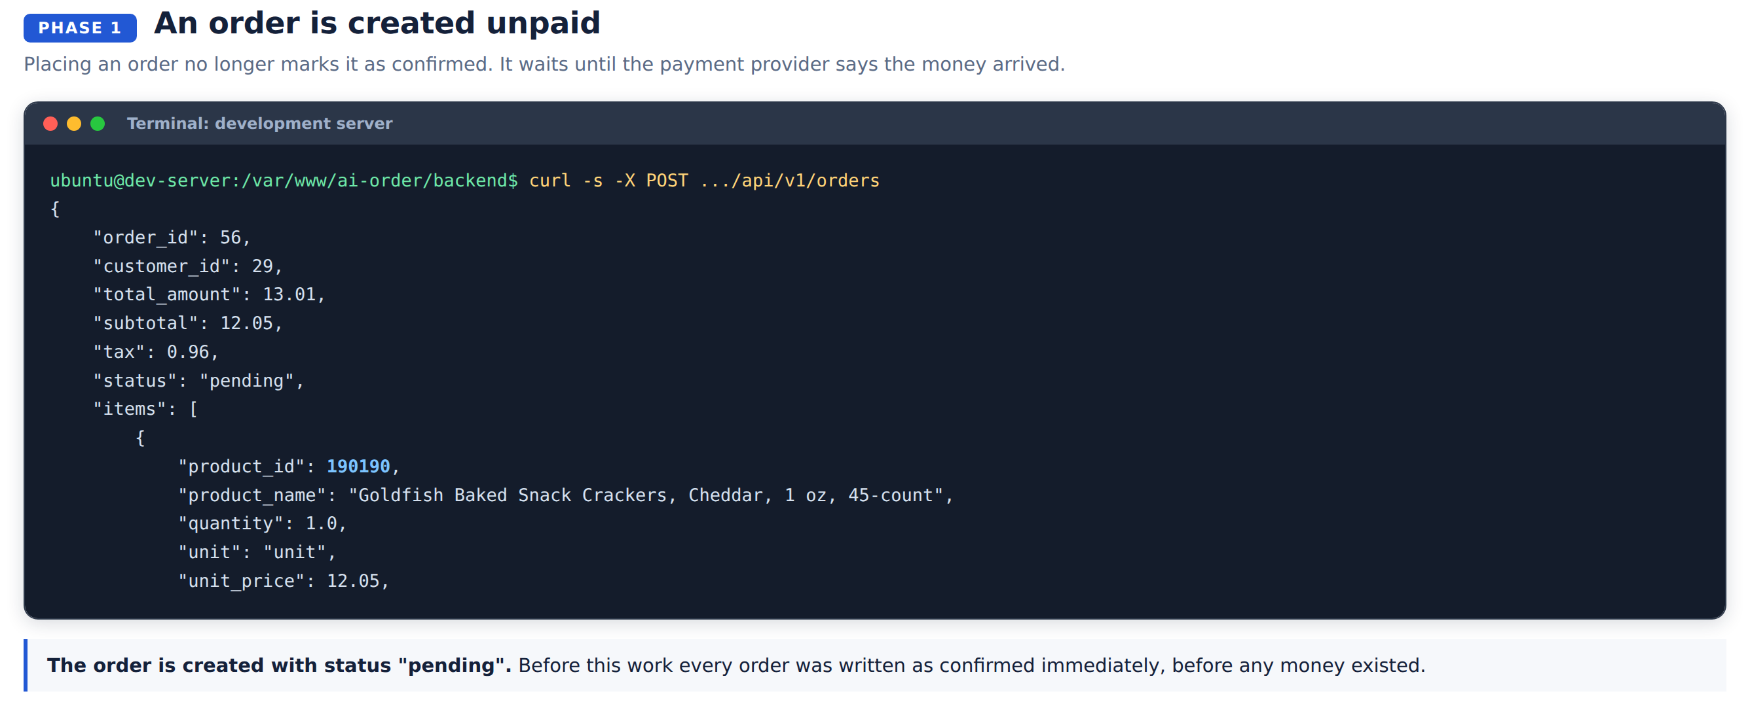

The double click
Each attempt carries a one-off key. The same key arriving again returns the order already created, and the database enforces it even if both arrive at once.
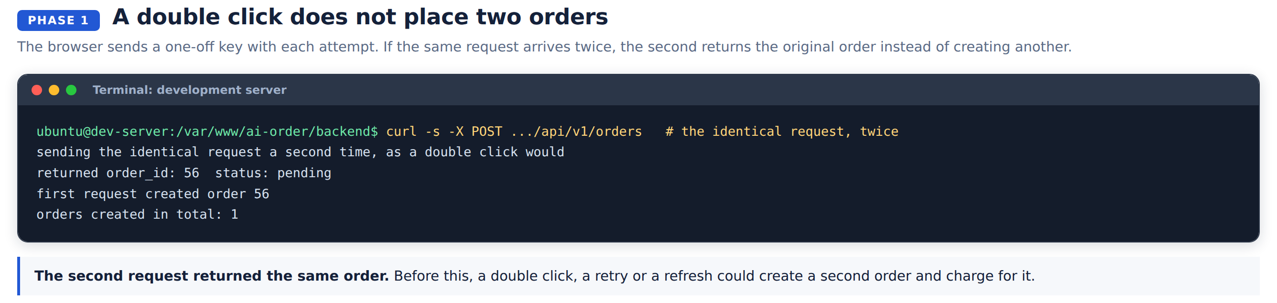

The overselling
Reducing stock is one database instruction that only succeeds if there is enough left. No gap between checking and taking.
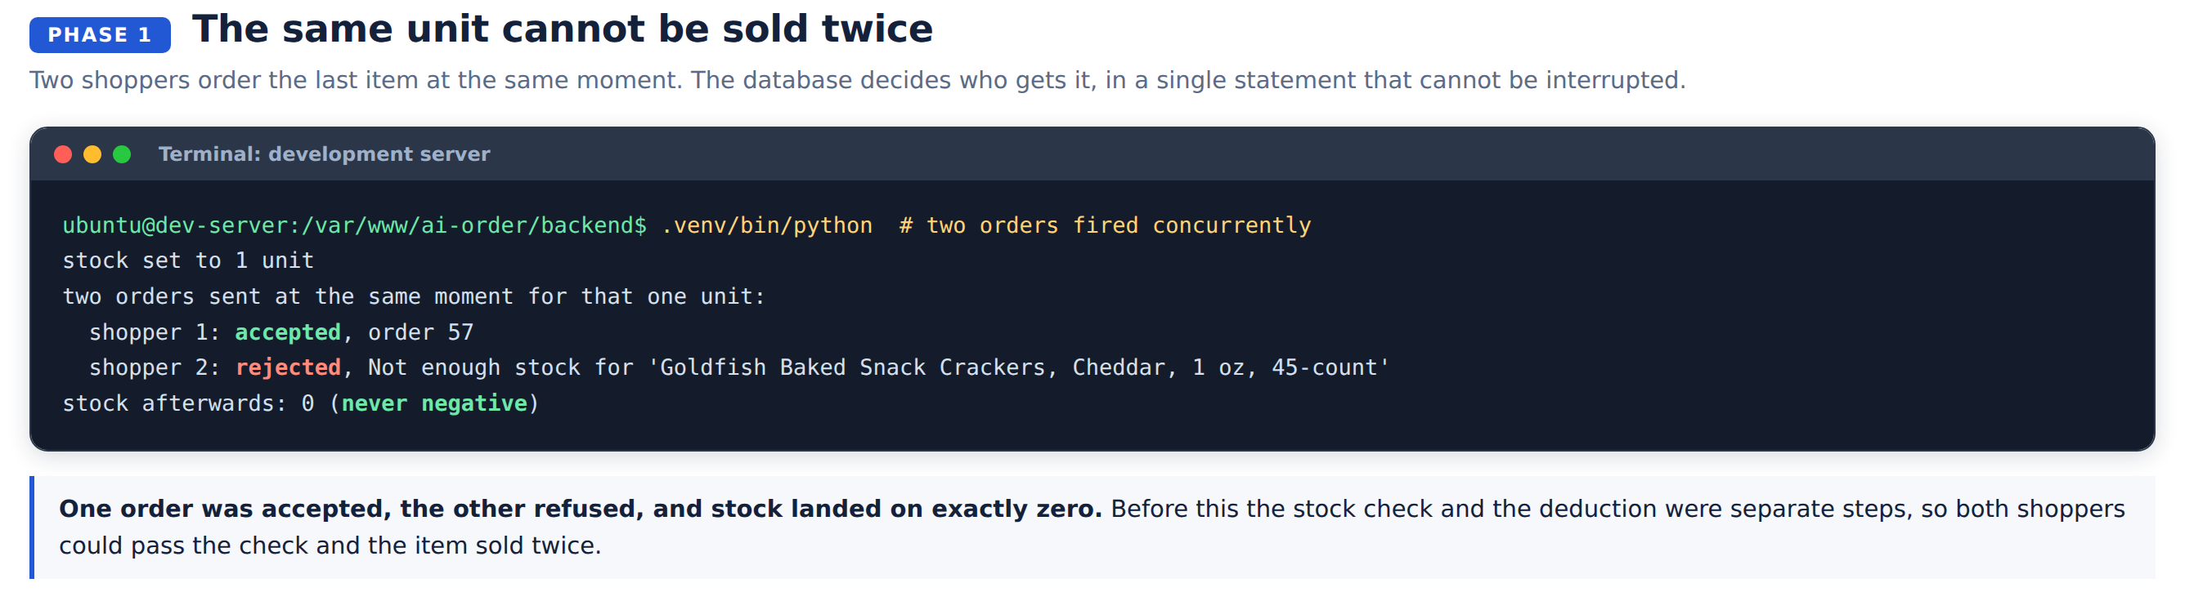

Trusting a payment confirmation
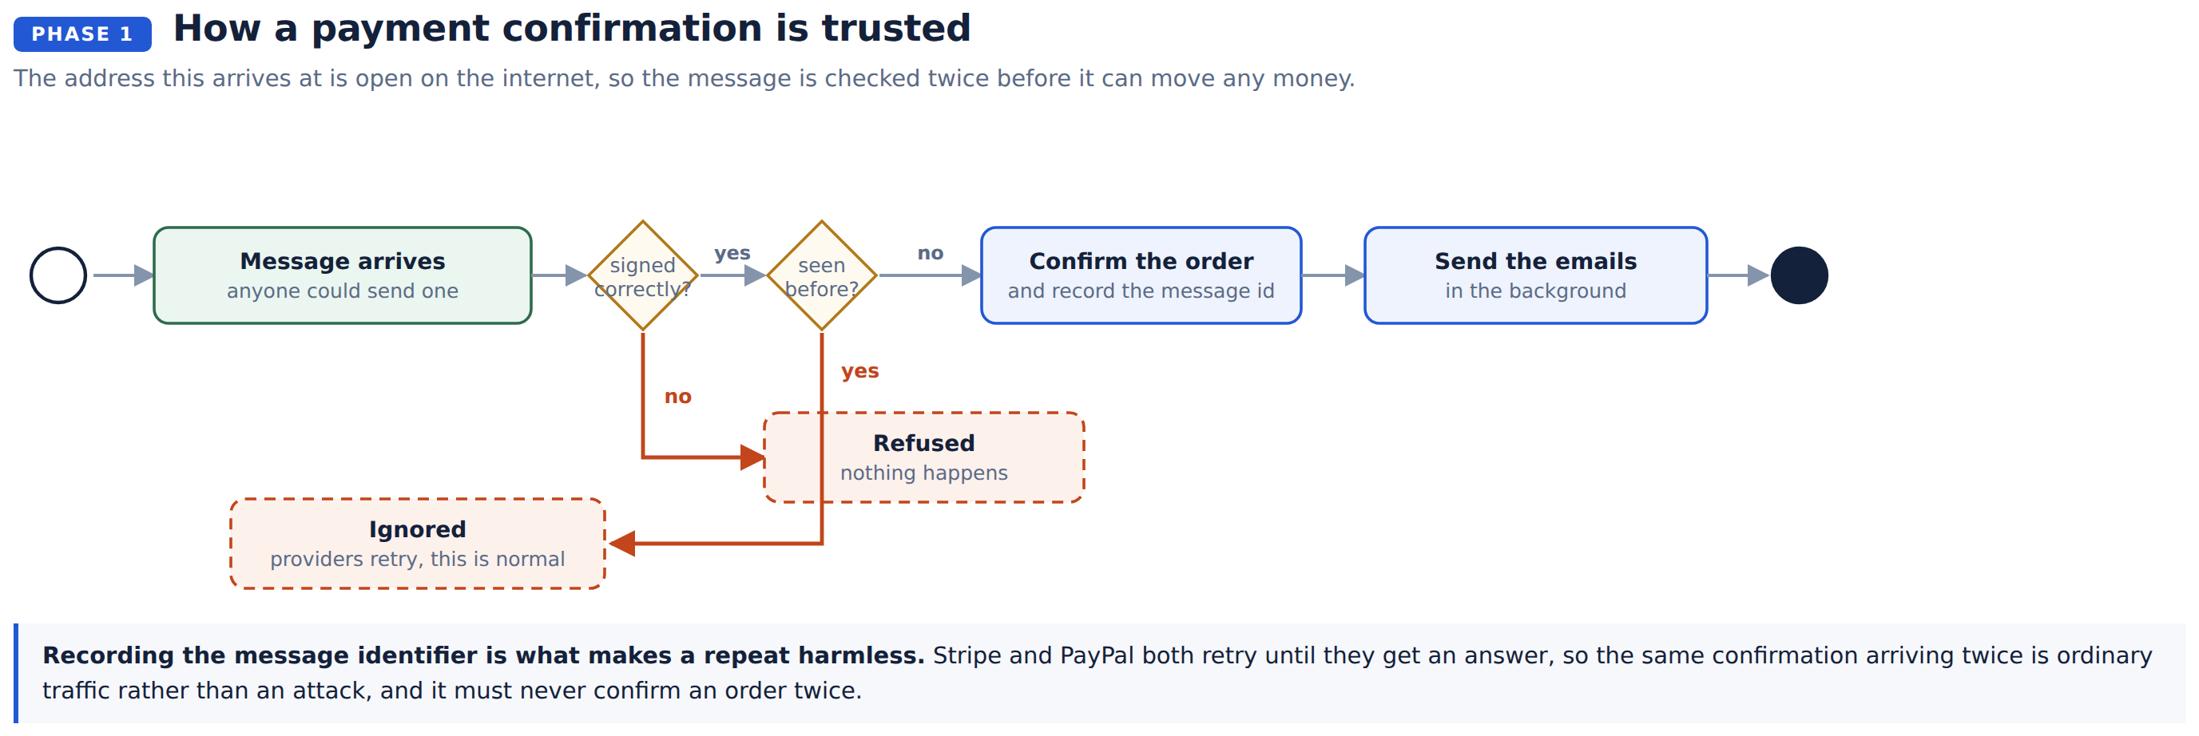
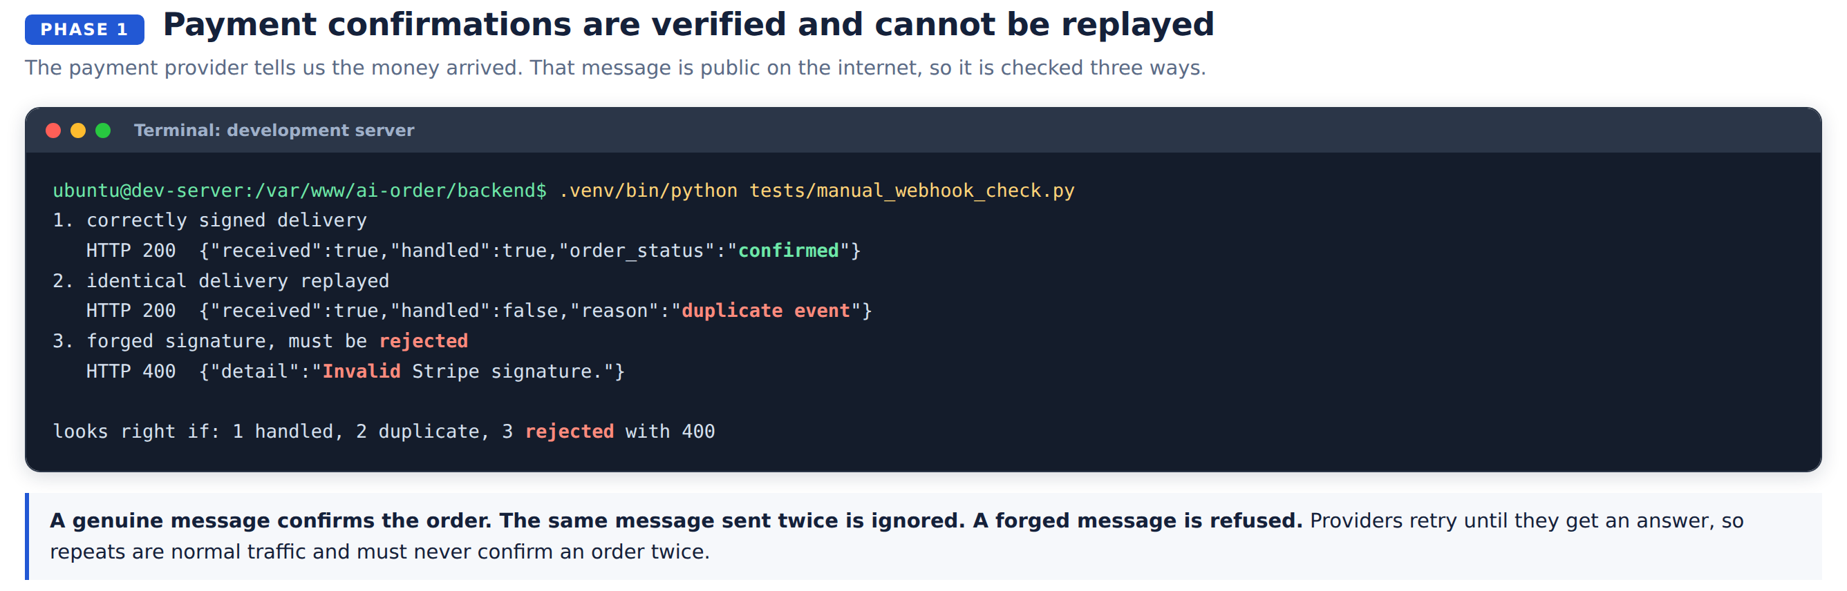

The staff view
A page at /admin listing orders, payment attempts and takings, with a count of orders awaiting payment. It is protected by a token that is entered once.
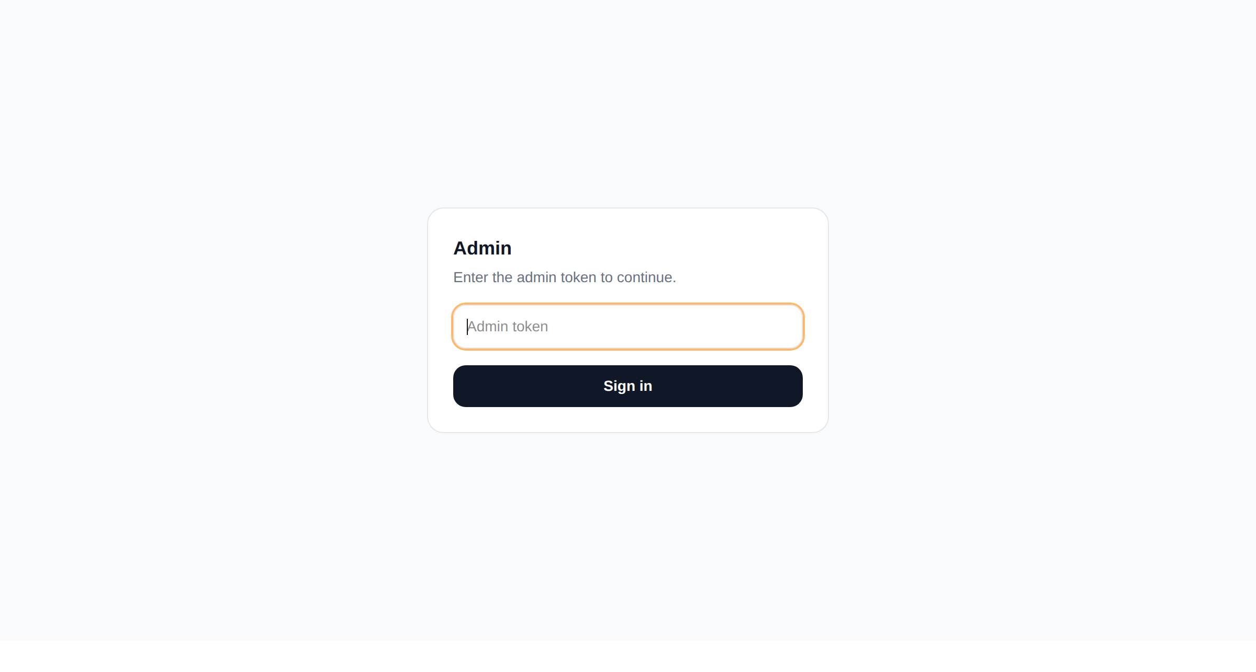

Phase 2. Products we do not stock

The problem
A shopper asking for something outside the catalog got whatever happened to share a word or two with what they asked for. No way to say "we can get it", and no record that anyone had asked.
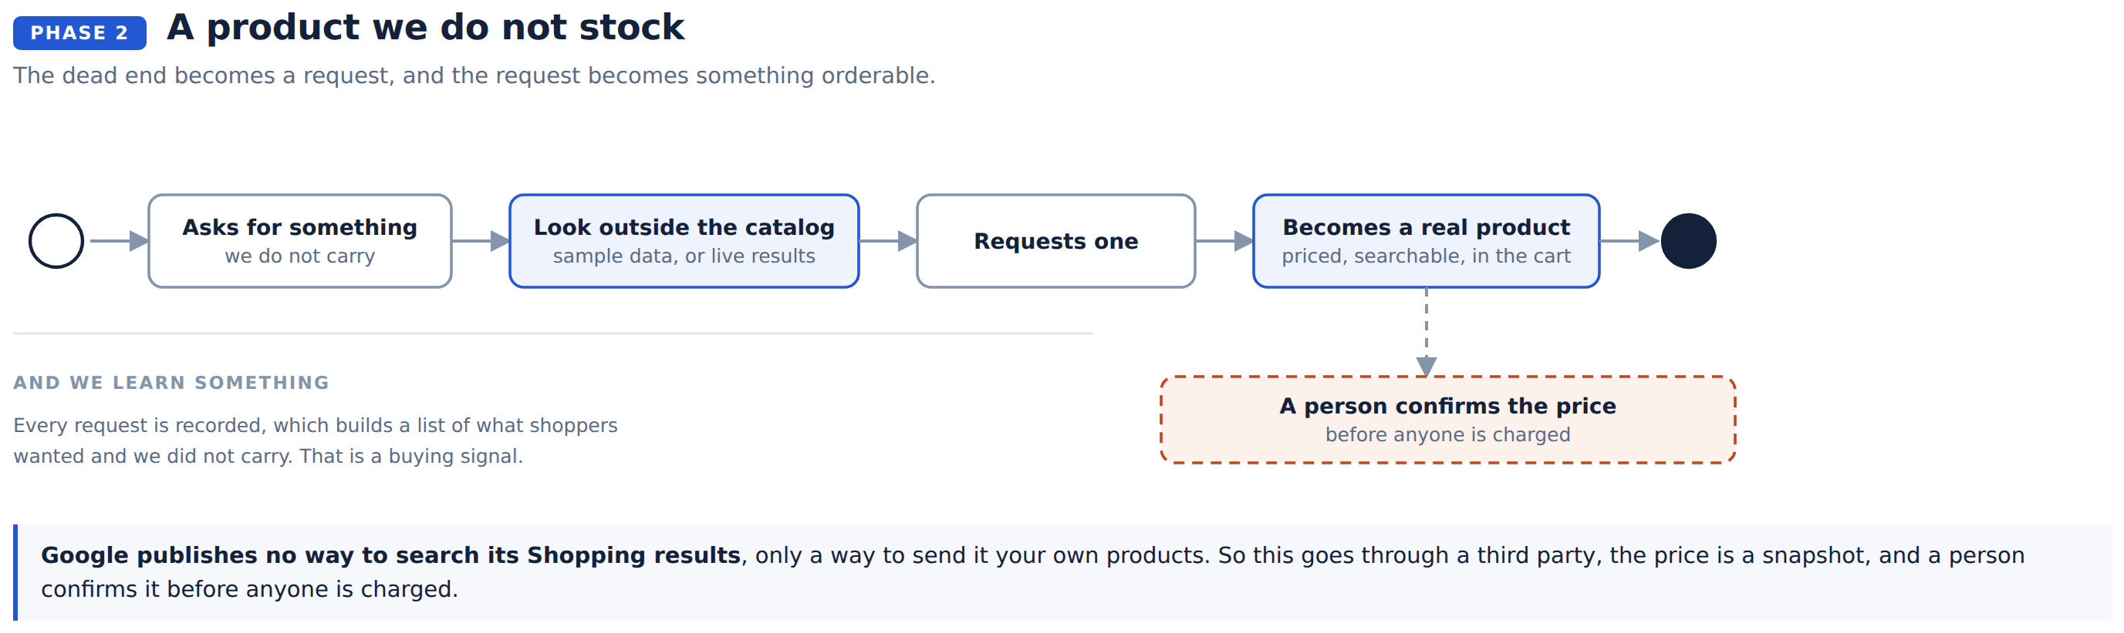
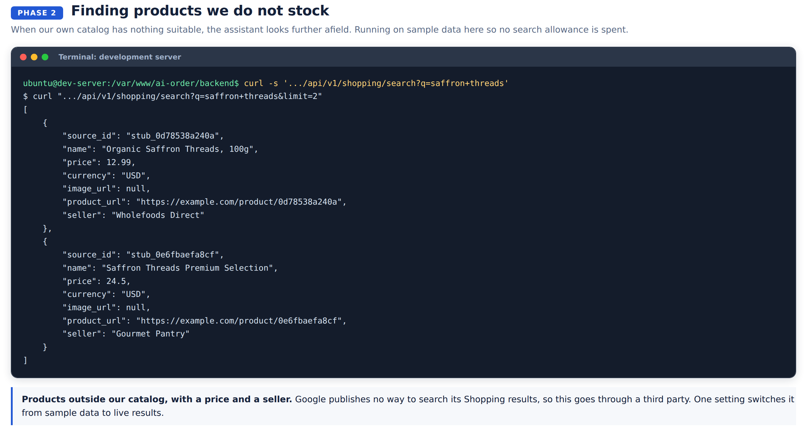
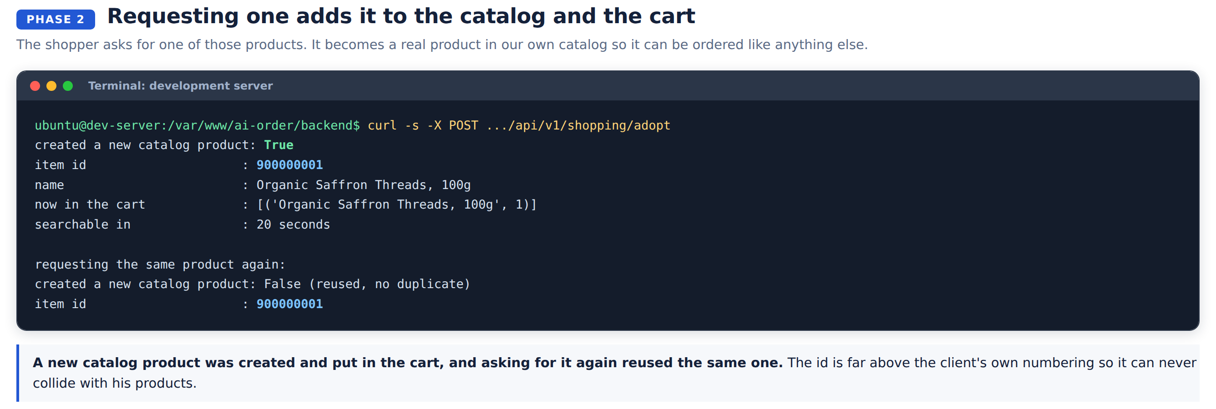

Two things the database made harder
Both found by checking the live database rather than trusting the description of it in the code.
What we assumed | What is true | What we did
The database numbers new products | It does not, they would all be zero and the second would fail | Number them from 900,000,000 up, clear of the client's own range
The picture field holds a web address | It holds thirty characters, enough for a filename | Widened it on our copy only

Deliberately not done
New products stay on our side and are not written into the client's catalog. His system numbers its own products, and writing into it needs his agreement first. The mechanism is designed and can be switched on when he is ready.

Phase 3. Speed

The problem
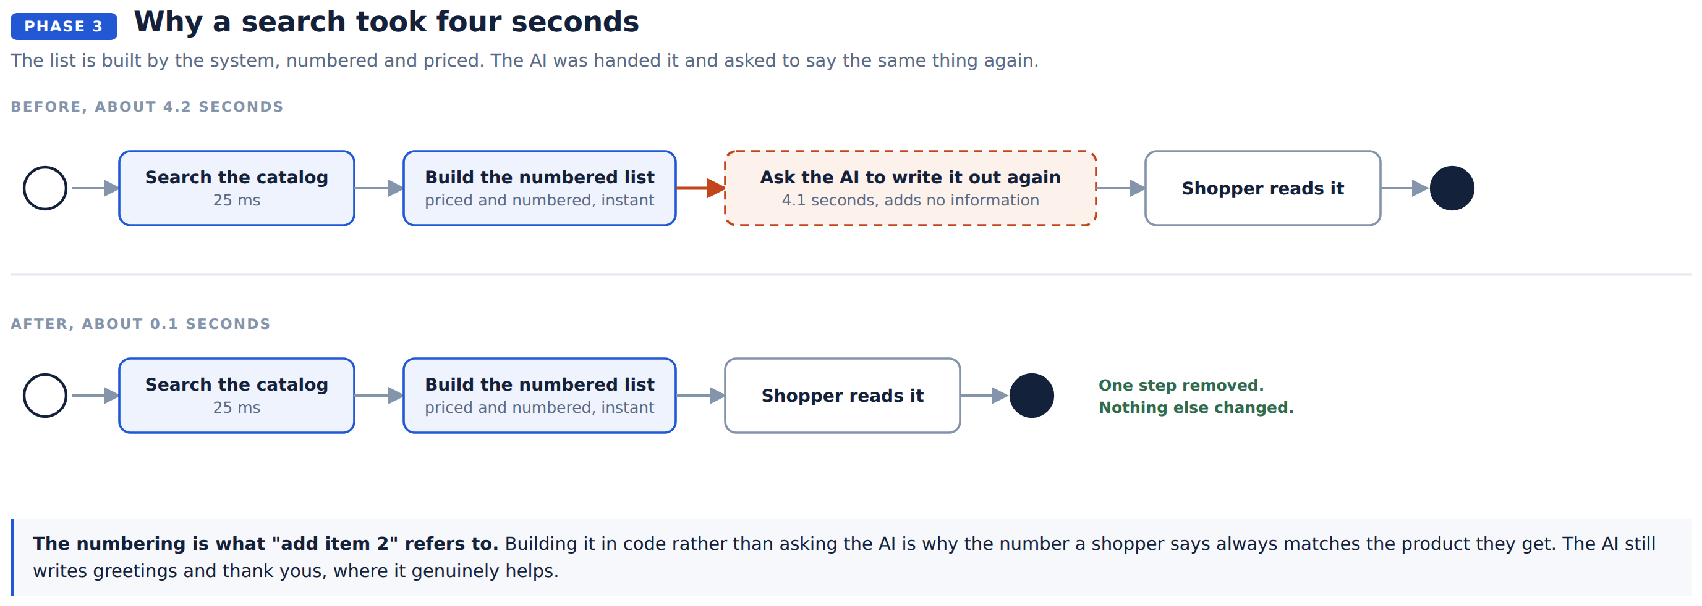
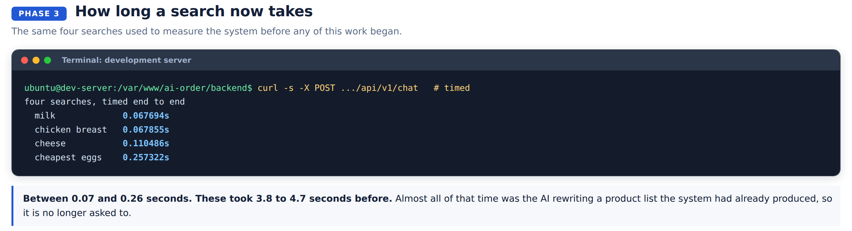
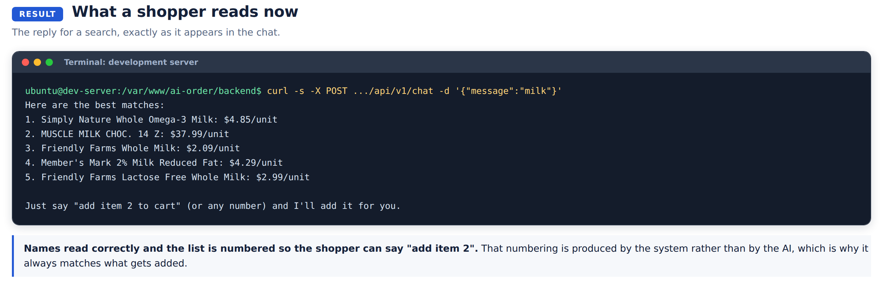

What is left
A correction worth making plainly. An earlier version of this document said a spoken reply took 3.2 seconds. That figure came from a test clip of three words, and it was not what shoppers were experiencing.
Watching real use showed two separate problems:
Problem | Cause | Fixed
Recordings ran to the 15 second limit | How loud counts as silence was a fixed number chosen in advance. In a room noisier than that number, the level never drops below it, so the turn never ends. | Yes. It now listens to the room first and sets the bar above whatever it finds.
One transcription in five took 13 to 21 seconds | The speech service itself, unrelated to how long the clip is. A clean clip never stalls. | Bounded. It now gives up after 12 seconds and asks the shopper to repeat, because a quick "say that again" beats a very slow answer.

So a shopper could finish speaking and then wait for the recorder to give up before anything was even sent. Measured again after the fix, a spoken reply takes about four seconds once they stop talking.
Going below that needs continuous streaming audio instead of a recording, which is a larger piece of work and has not been started.

Product names
2,292 of the 25,631 product names contained a question mark where another character belonged, so shoppers read "Member?s Mark". The original character is genuinely gone: it is stored as a literal question mark, and the client's own database has the same.
1,919 of them were apostrophes and have been repaired. The remaining 381 are accented letters and symbols, not apostrophes, and replacing those blindly would make them worse:
Stored | Should be | A blanket replace would give
Jalape?o | Jalapeño | Jalape'o
Nestl? | Nestlé | Nestl'
Cr?me | Crème | Cr'me
Enfamil? | probably a trademark symbol | Enfamil'

Those 381 span 110 different words and need a decision per brand, so they were left alone. The repair script lists them.
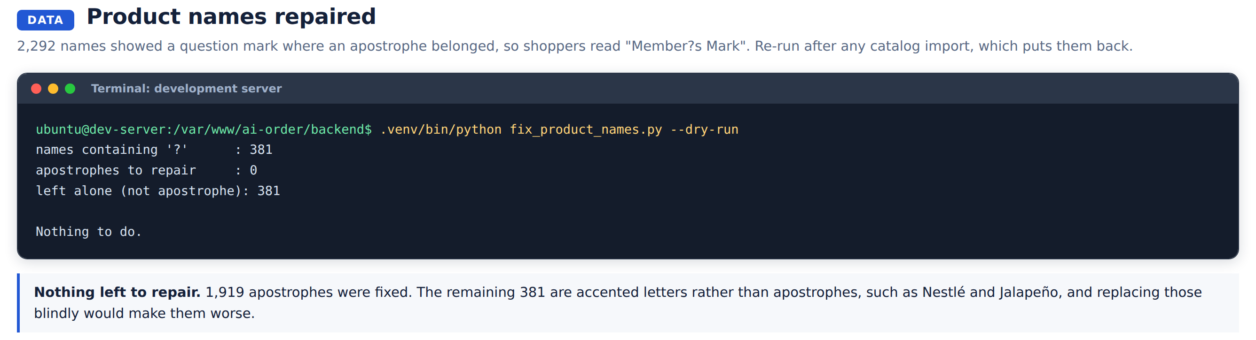
Two things to know. This fixes our copy only; the client's own data still has the broken names. And a catalog import copies his names over ours, so the repair has to be re-run after each import. It is written to be safe to run repeatedly.

Testing

The automated tests
These run in about a second and are checked on every change. They went from 38 to 104.
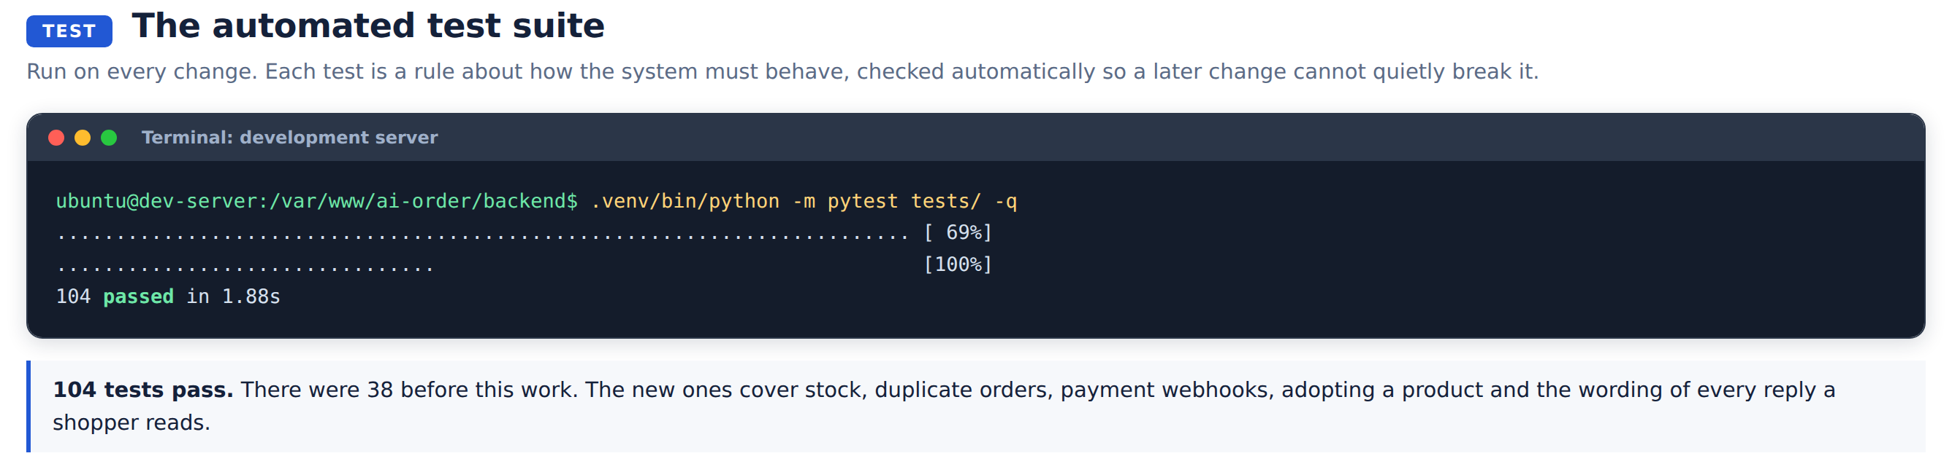
What is tested | Tests | Covers
Stock and orders | 14 | Overselling, releasing stock after a failed payment, duplicate orders, one customer per email
Adding a product from elsewhere | 18 | Product numbering, required fields, no duplicates, over-long picture addresses
Reply wording | 34 | Every reply a shopper can see, numbering matching the list, no stray characters
Understanding what was said | 18 | "add item 2" and "add item two" meaning the same thing
Catalog search | 20 | Results identical to the old method, category filters, empty catalog

Checks run on the live development server
Each of these was run against the running system, not in isolation.
Check | Result
Both services running, catalog loaded | Pass, 25,631 products
Payment methods available | Pass, Stripe and PayPal
An order is created unpaid | Pass, status "pending"
The same request twice | Pass, returned the original order
Two shoppers, one unit left | Pass, one accepted, one refused, stock zero
A genuine payment confirmation | Pass, order confirmed
The same confirmation replayed | Pass, ignored
A forged payment confirmation | Pass, refused
Searching outside the catalog | Pass, results returned
Requesting one of those products | Pass, created and added to the cart
Requesting the same one again | Pass, reused, no duplicate
Search speed | Pass, 0.07 to 0.26 seconds
Product names | Pass, nothing left to repair
Test data removed afterwards | Pass, catalog back to 25,631

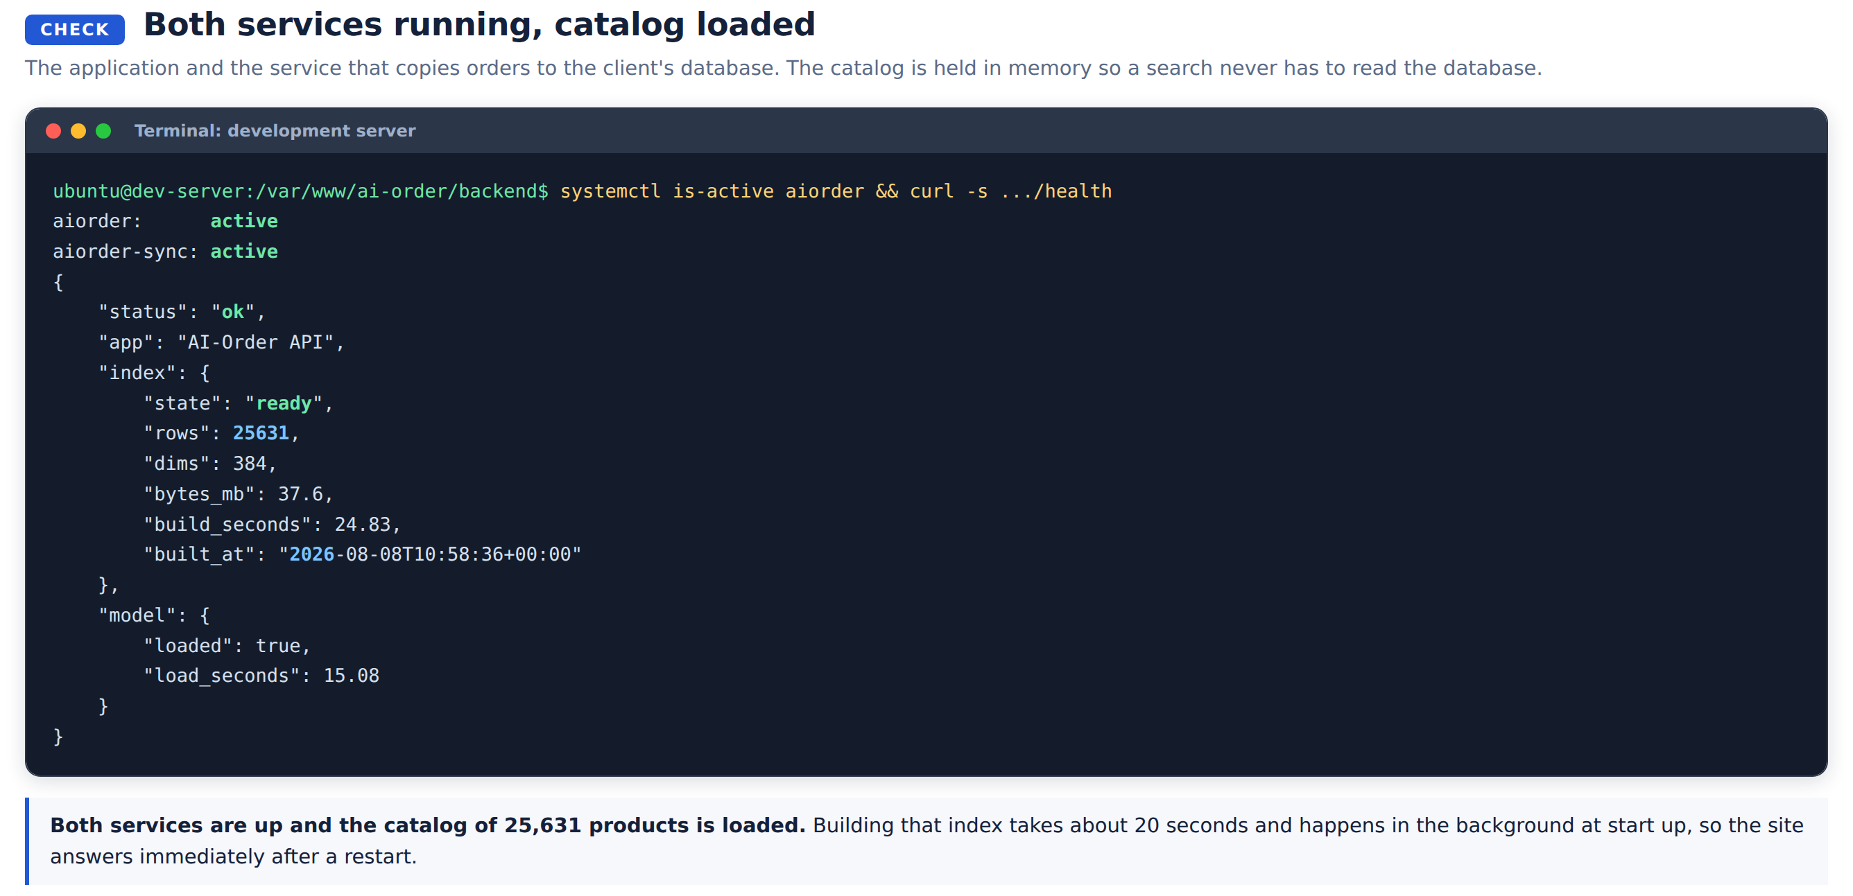
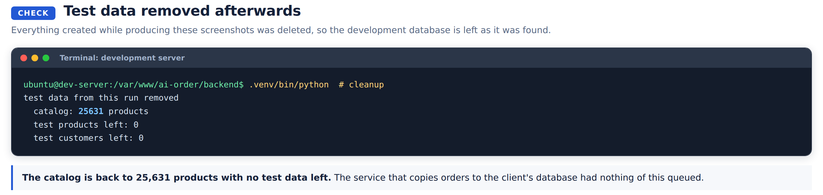

What was tested and rejected
Not every experiment was kept. Two were tried and abandoned, both recorded here because the reasoning matters as much as the result.
A faster model for understanding speech. It saves about half a second per spoken reply and mishears more often. A misheard order costs more than half a second saves.
Replacing every question mark in a product name. It would have repaired 1,919 names and damaged 381 others.

What has not been tested
Stated plainly so nothing here is taken for more than it is.
- A real card payment through to completion. Everything up to the Stripe payment page is verified, and a correctly signed confirmation is verified. The one step not driven end to end is a real card producing a real confirmation. This needs a person at a browser and takes under a minute.
- The voice recording on a real phone. The recording and playback were tested through the interface, not by speaking into a handset. This matters more than it did: the fix for recordings running to the time limit is reasoned and deployed but has not been confirmed with a real microphone. The server log now reports the length of each clip, so a clip still arriving at 15 seconds would show immediately.
- The off-catalog search against live Google results. It runs on sample data by default so no search allowance is spent. The connection to the live service is a single setting, and the code path either way is identical.

Where things stand

Running now
Payment through Stripe and PayPal on test credentials. Requesting products we do not stock. Searches answering in under a quarter of a second. The staff view. The repaired product names.

Needs a decision
Going live with payments | Which country the business is registered in, and when to swap the test credentials for real ones
Appearing in Google | Whether product barcodes exist anywhere in the product data. Without them a Google listing cannot be submitted
Requested products | Who confirms the price and availability, and how the shopper is told
How the assistant sounds | Six to ten replies written in the voice it should have. Worth more than any technical change

Known and not addressed
- 381 product names still contain a question mark standing in for an accented letter.
- The client's own copy of the product names is unchanged.
- A shopper is not recognised when they return, so there is no order history and no reordering.
- Product pages do not exist, which is what blocks appearing in Google search results.
- Real units are stored but not used, so receipts say "2 unit" rather than "2 kg".
- Discounts are stored per product and never applied.

