AI-Order | Conversational Shopping Assistant
Search Speed: Summary
Milestone 1, in-memory catalog index. Measured results.
Prepared by: Abad Naseer
Project: AI-Order (SmartMarket) conversational shopping assistant
Environment: Development, dev.agent.fordev.fun
Catalog size at time of measurement: 25,631 products

Result
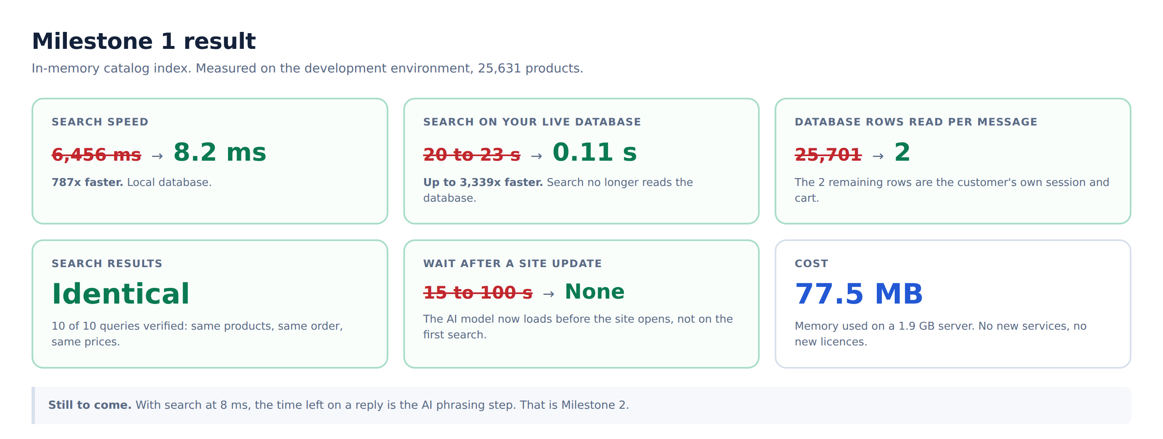
Milestone 1 measured on the development environment

Before
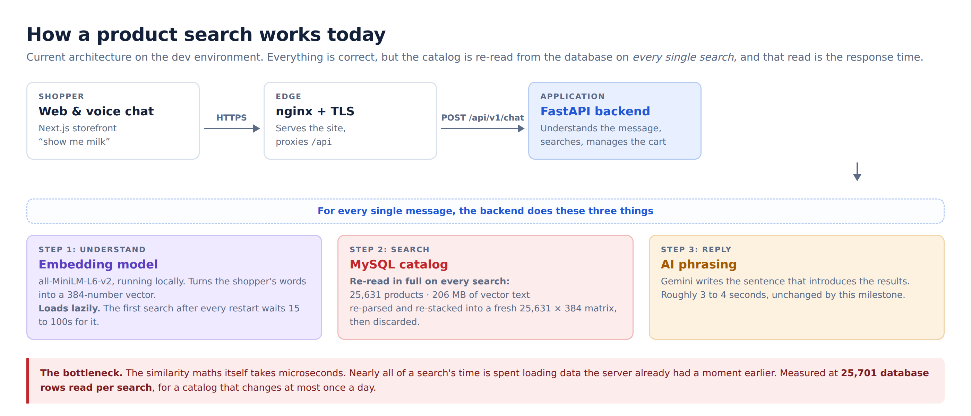
Every search re-read all 25,631 products from the database

After
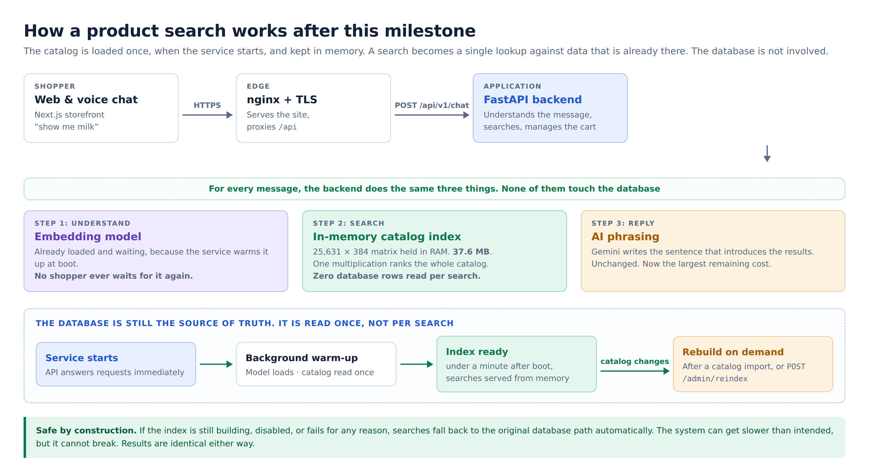
The catalog is loaded once at start-up and held in memory

A real search
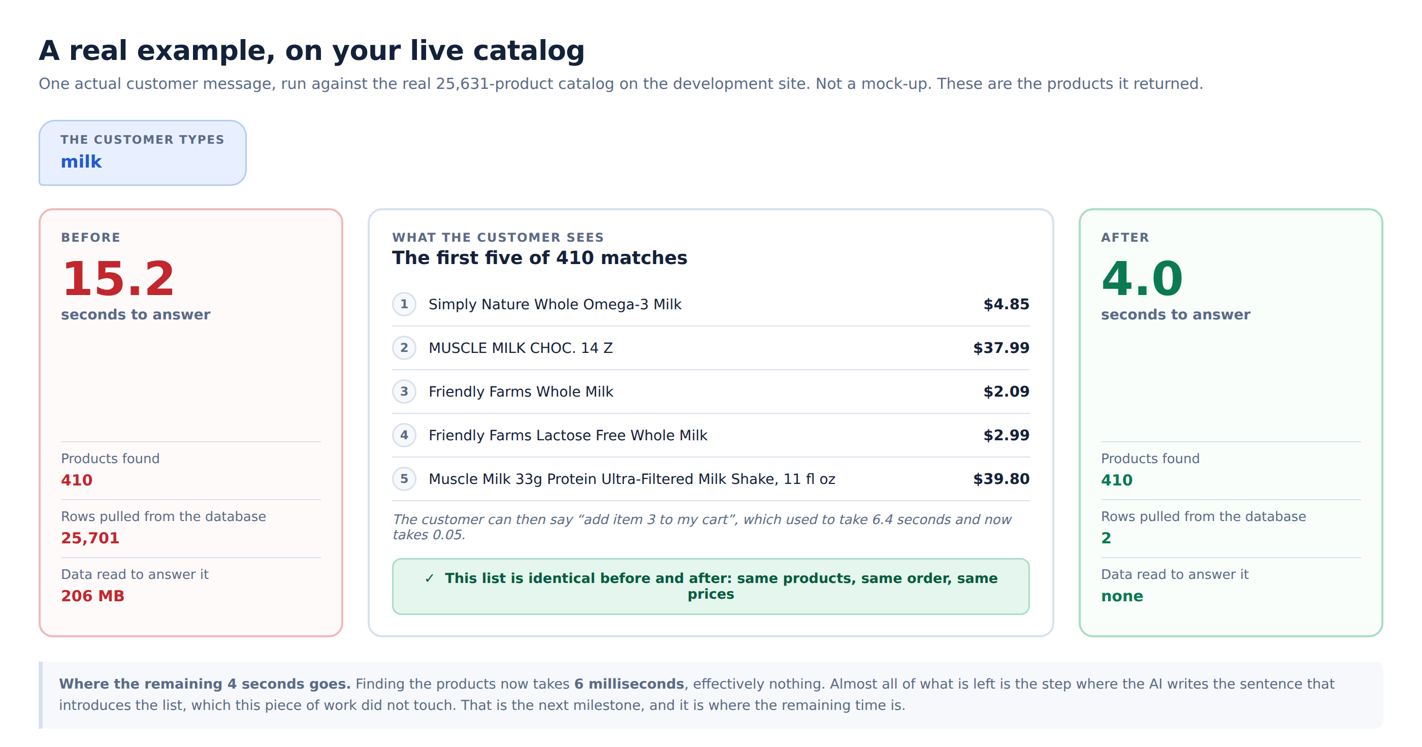
The query "milk" on the live 25,631 product catalog

The results did not change
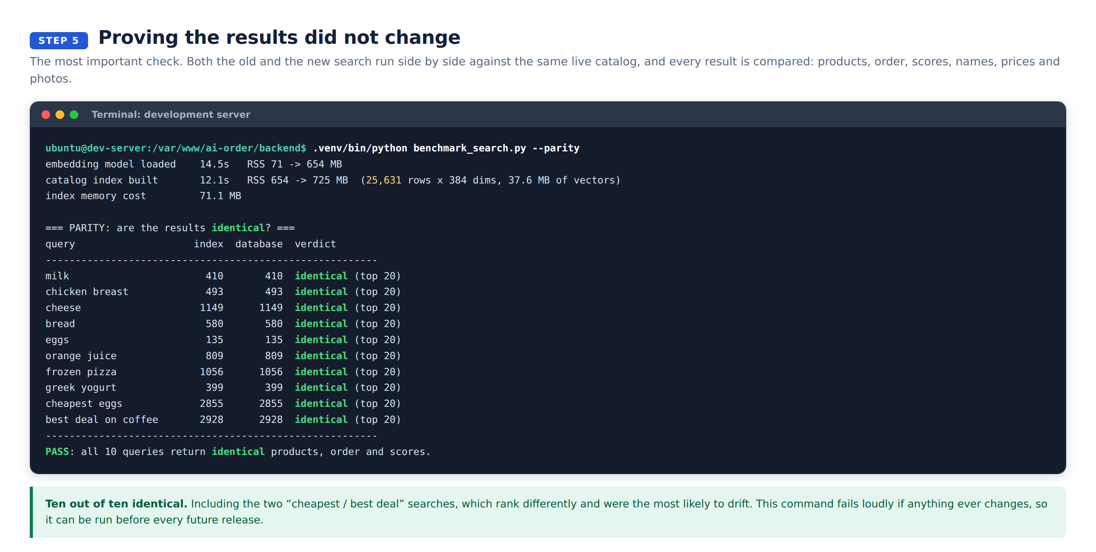
Old and new compared product by product

Next
Milestone 2: reply speed. Search now takes 8 ms. The time left on a reply is the AI phrasing step, which this milestone did not touch.
Measured 0.2 seconds end to end when that step is skipped.
Needed from you: the Gemini key on dev is over quota (HTTP 429).

