AI-Order | Conversational Shopping Assistant
Search Speed: How It Works
The search, one message end to end, and start-up.
Prepared by: Abad Naseer
Project: AI-Order (SmartMarket) conversational shopping assistant
Environment: Development, dev.agent.fordev.fun
Catalog size at time of measurement: 25,631 products

Inside the search
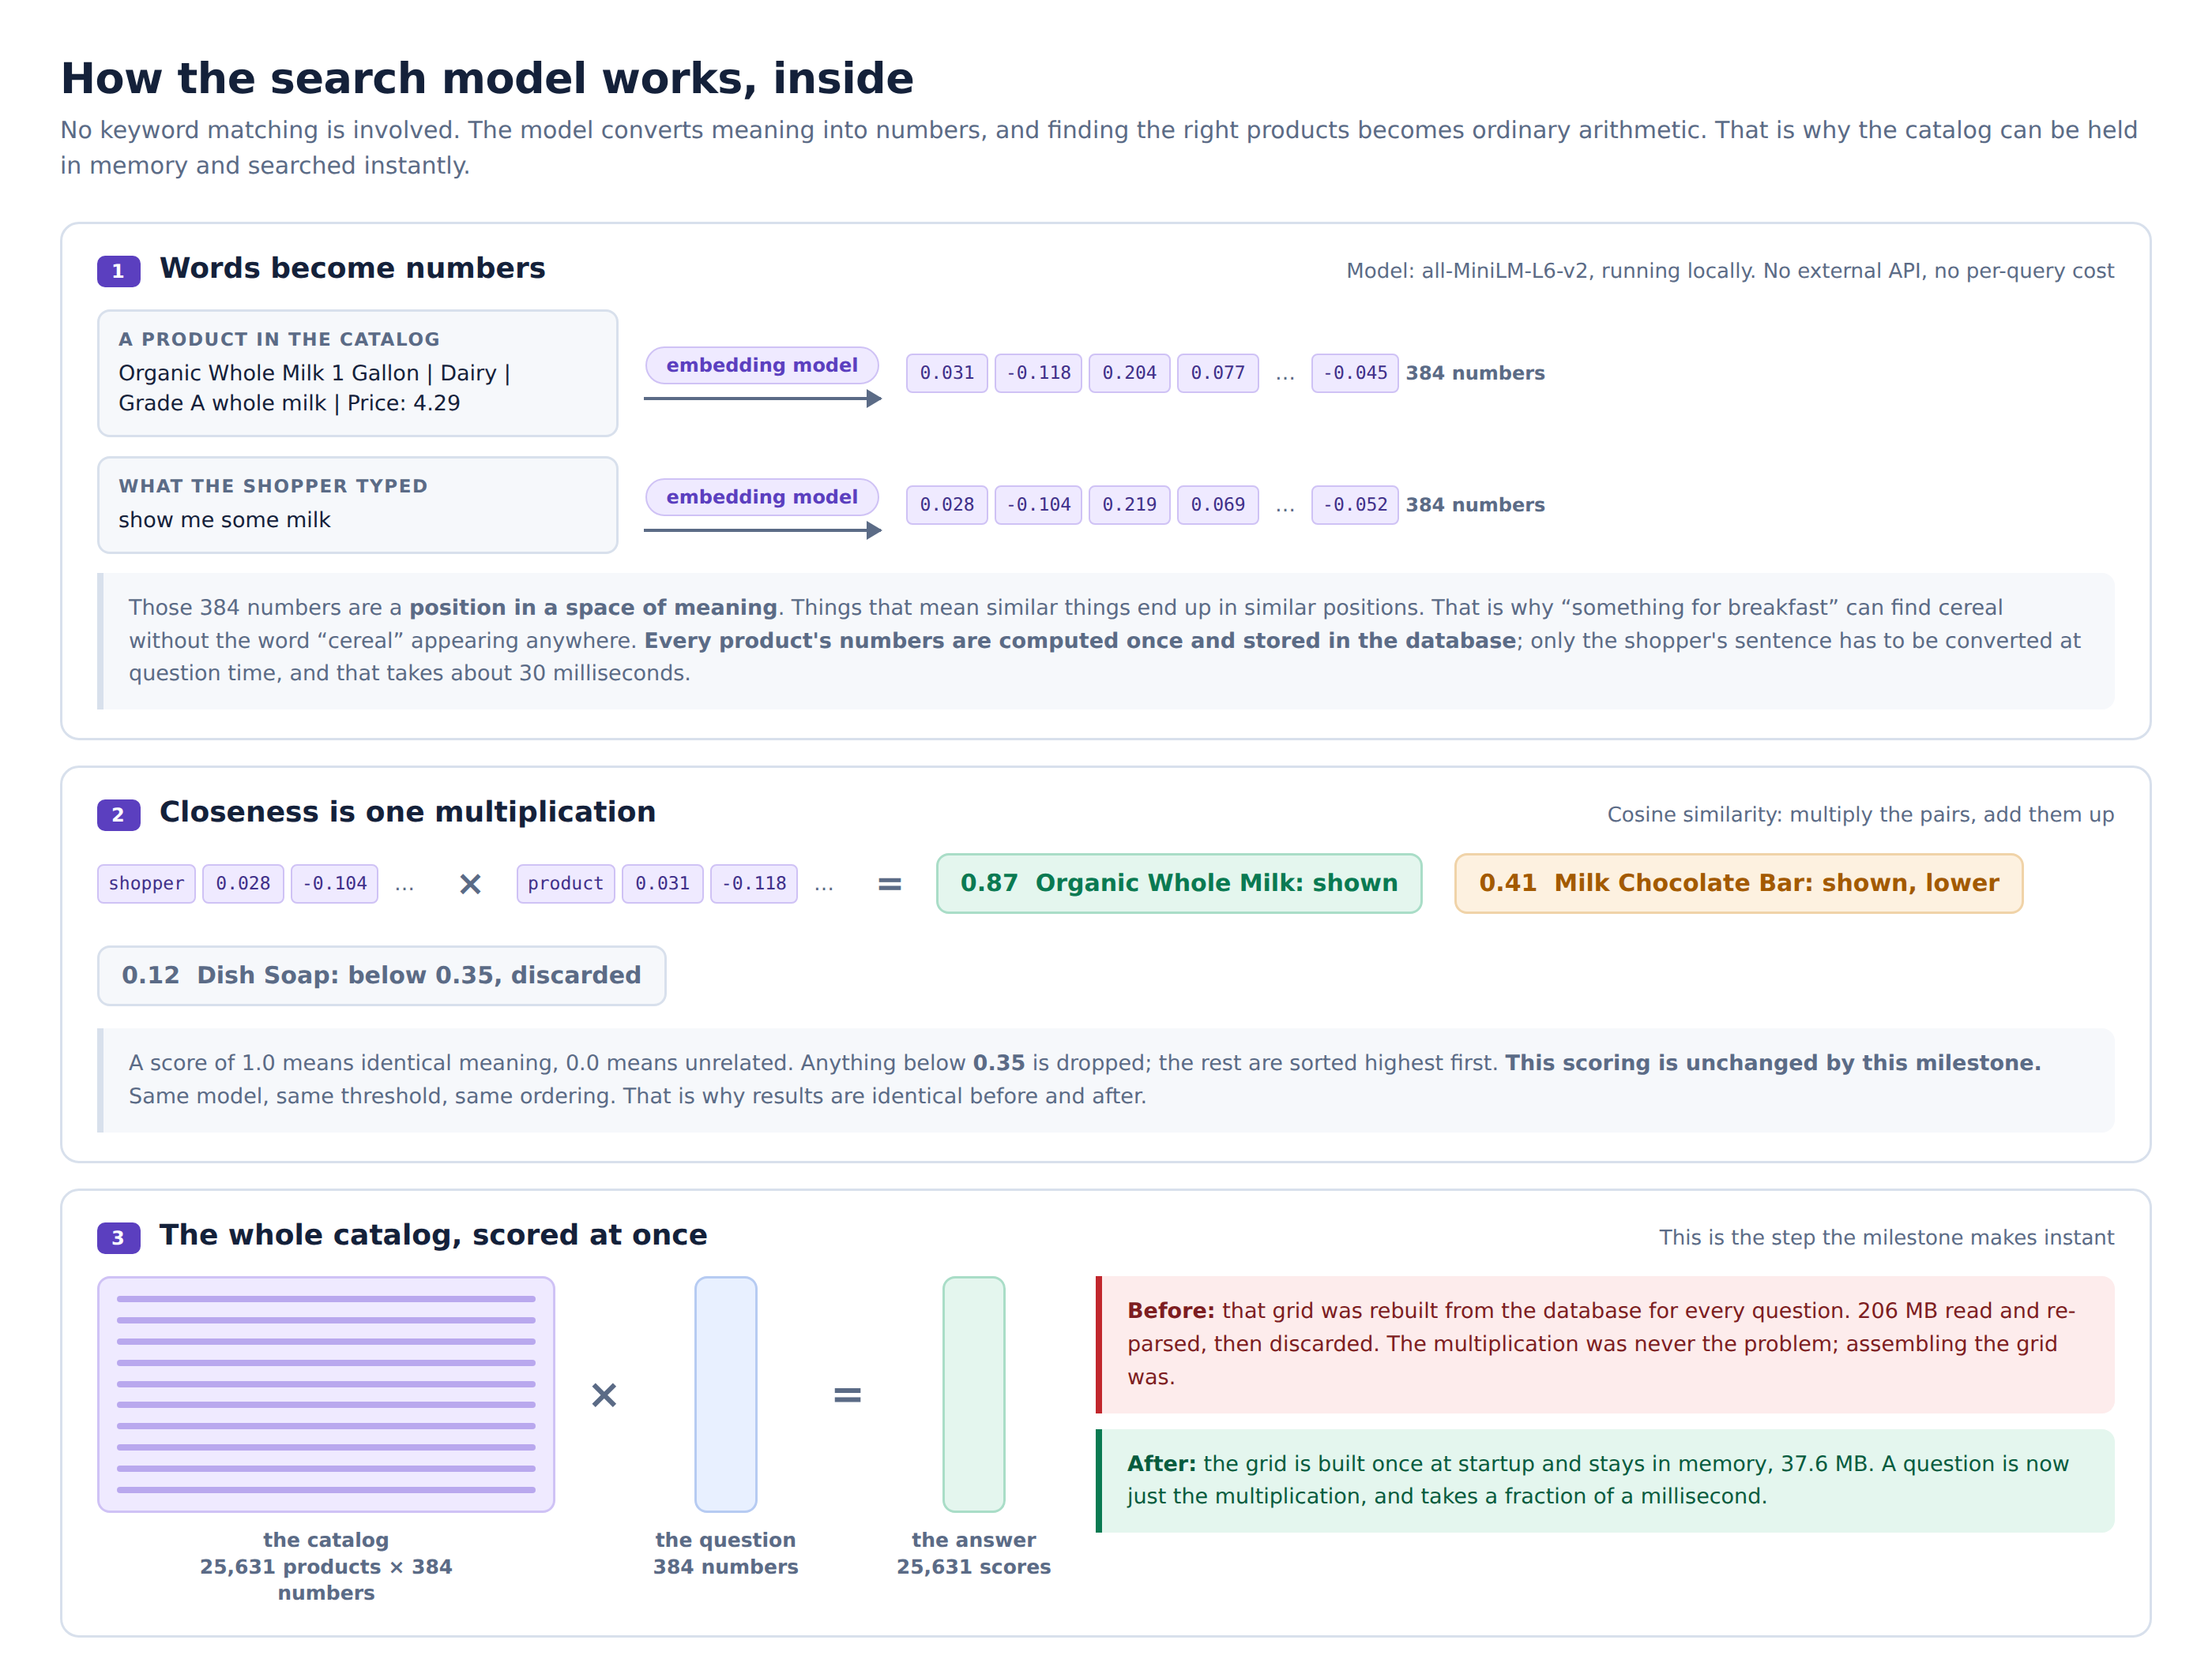
Words become numbers, and matching becomes arithmetic

One message, step by step
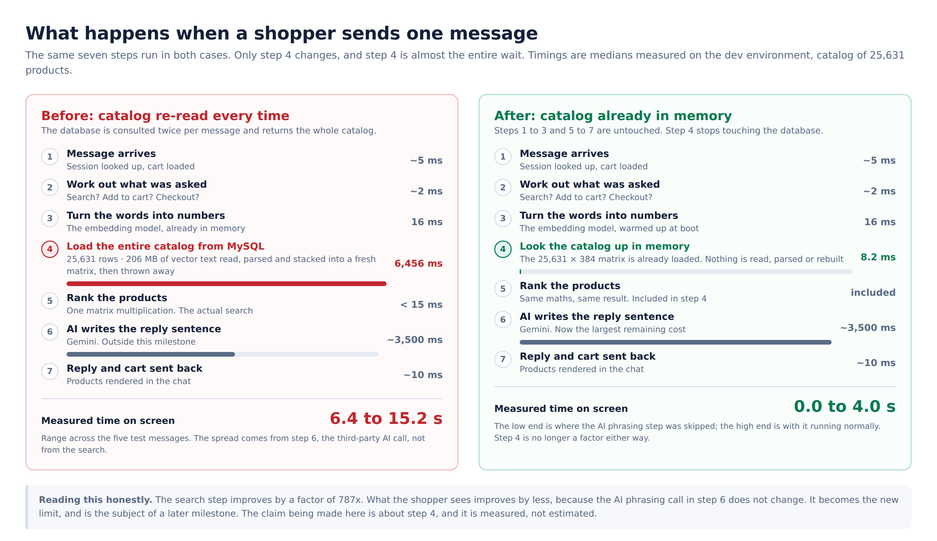
The same seven steps before and after. Only step 4 changes

Start-up, rebuilds and failure
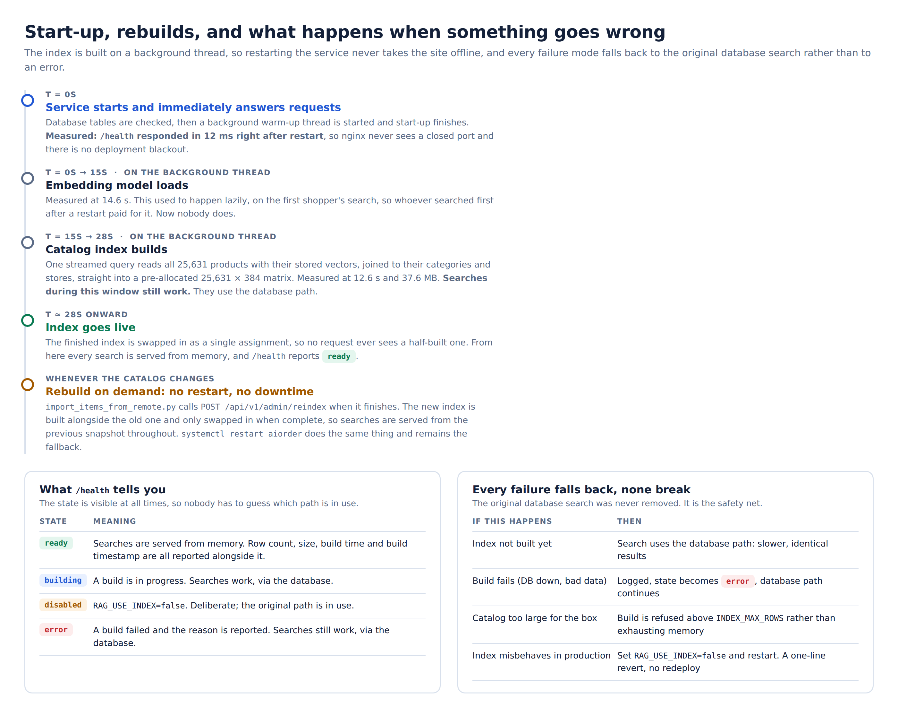
What happens on restart, on a catalog update, and when something goes wrong

