AI-Order | Conversational Shopping Assistant
Search Speed: What We Did
The code change, and every command that was run.
Prepared by: Abad Naseer
Project: AI-Order (SmartMarket) conversational shopping assistant
Environment: Development, dev.agent.fordev.fun
Catalog size at time of measurement: 25,631 products

Every screenshot below is the real output of a command run on the development server.

The code change
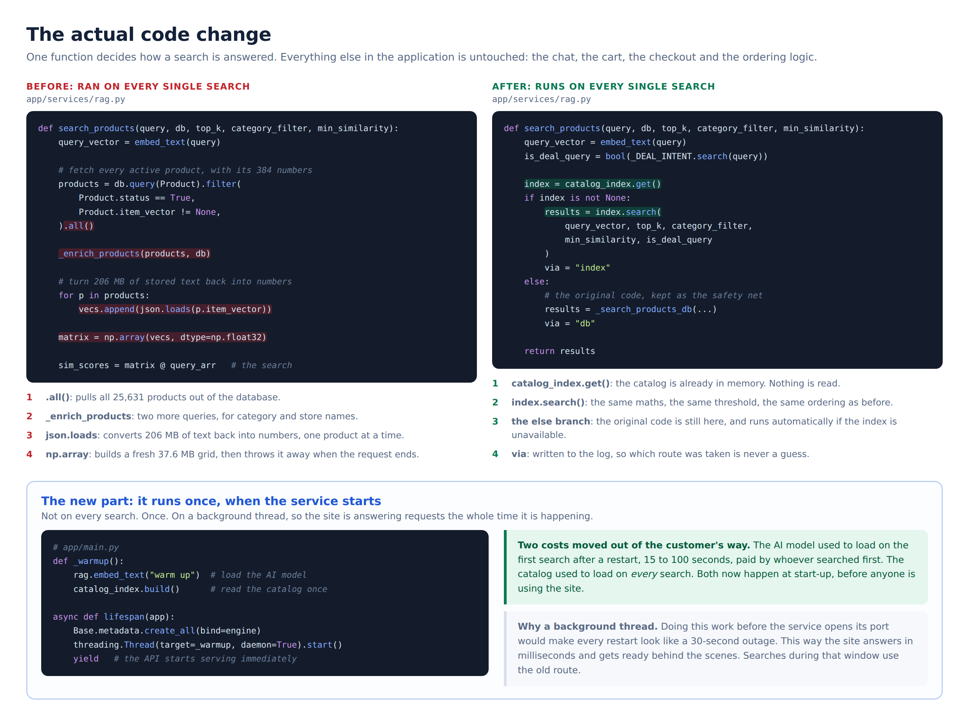
One function decides how a search is answered

Files touched
File | Change
app/services/catalog_index.py | New. Holds the catalog in memory and searches it.
app/services/rag.py | Checks memory first. Original database search kept as fallback.
app/main.py | Loads the AI model and catalog at start-up. Reports status on /health.
app/api/admin.py | New. Reloads the catalog without a restart.
app/core/config.py | Four settings, including the on/off switch.
app/services/media.py | Product photo URLs resolved from plain fields.
import_items_from_remote.py | Reloads the catalog after an import.
tests/test_catalog_index.py | New. 20 automated tests.
benchmark_search.py | New. Proves results are identical, measures the difference.
benchmark_live_db.py | New. Same measurement against the live database.

Chat, cart, checkout and ordering were not modified.

Step 1. Where the time was going
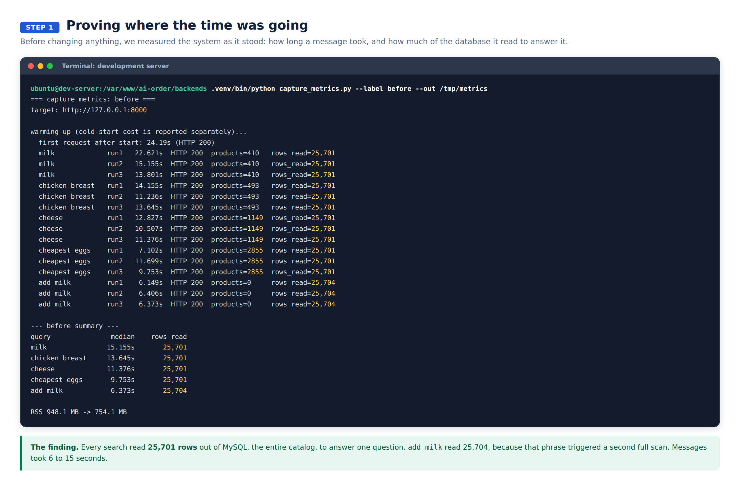
Baseline measurement

Step 2. Deploying
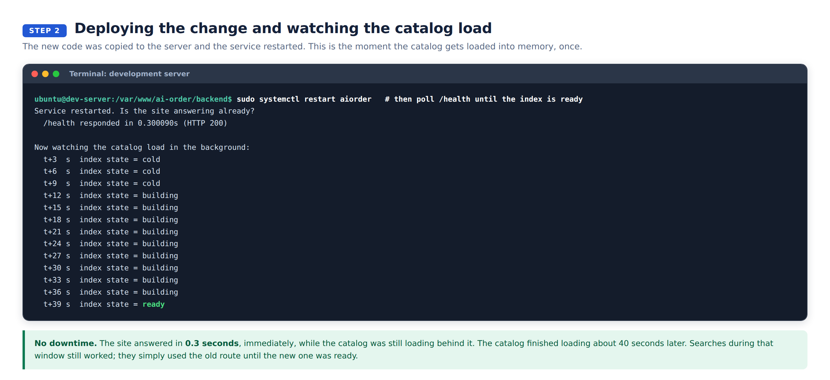
Restart, then the catalog loads in the background

Step 3. Status page
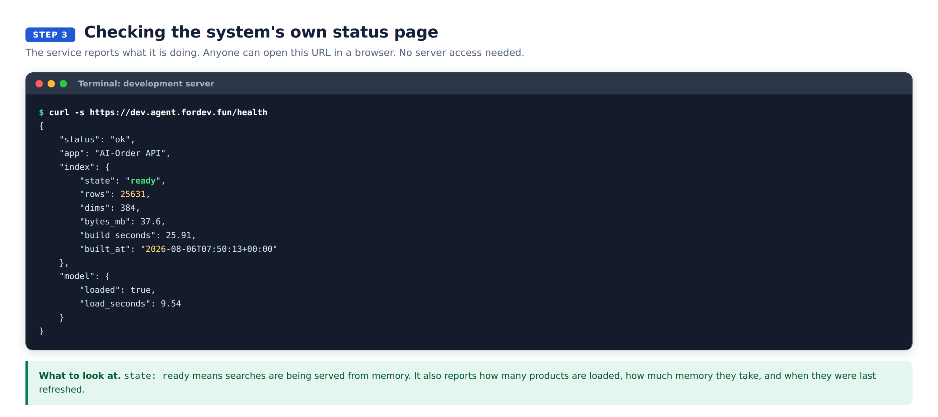
https://dev.agent.fordev.fun/health
Open this URL in a browser at any time.

Step 4. Live searches in the log
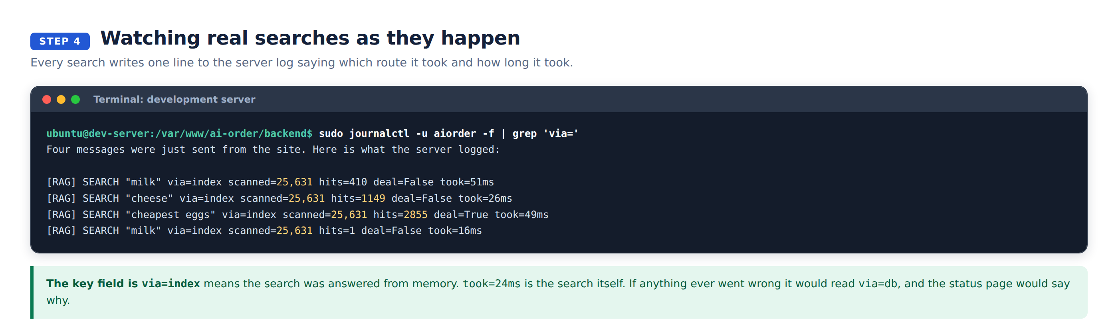
One line per search

Step 5. Results are identical
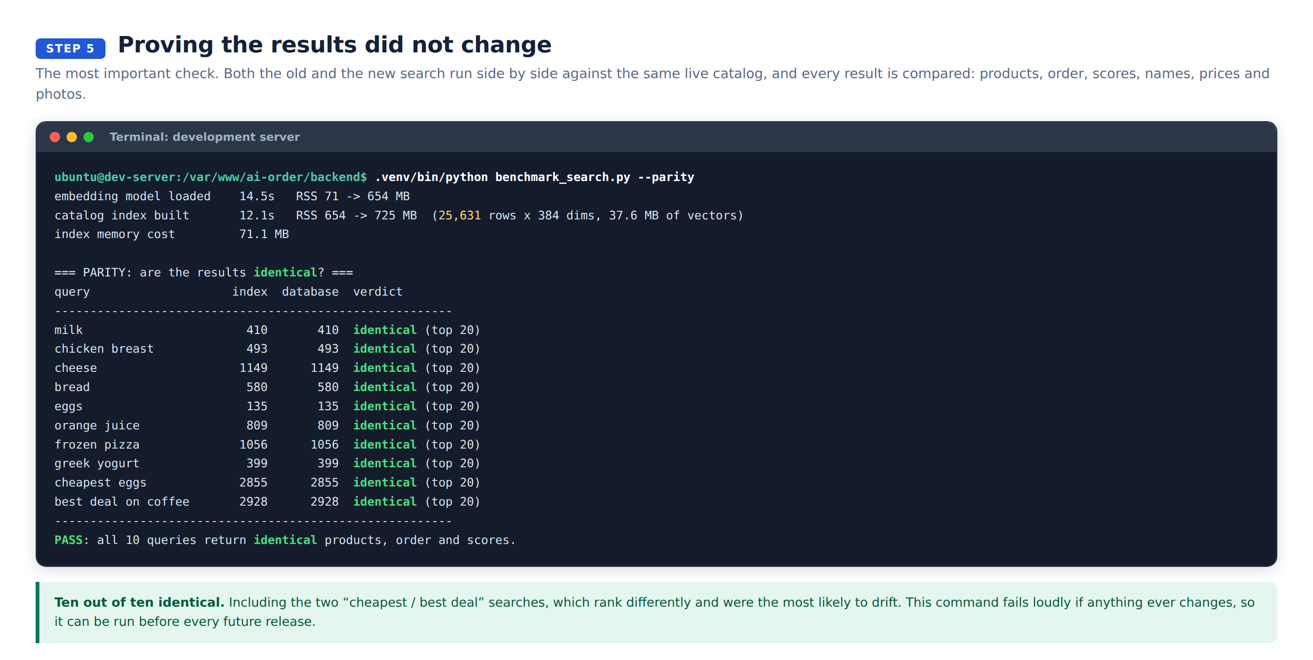
Old and new compared product by product

Step 6. Speed
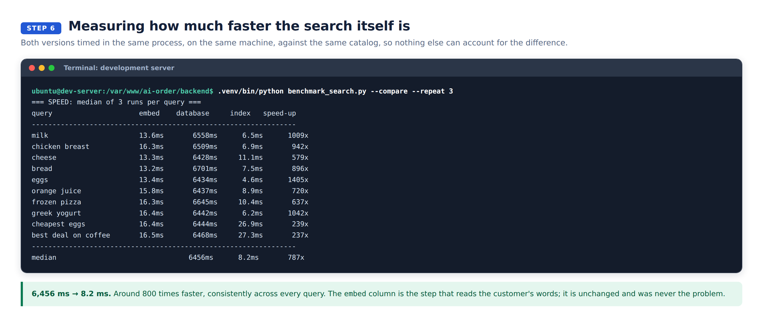
Both versions timed in the same process

Step 7. The first measurement, re-run
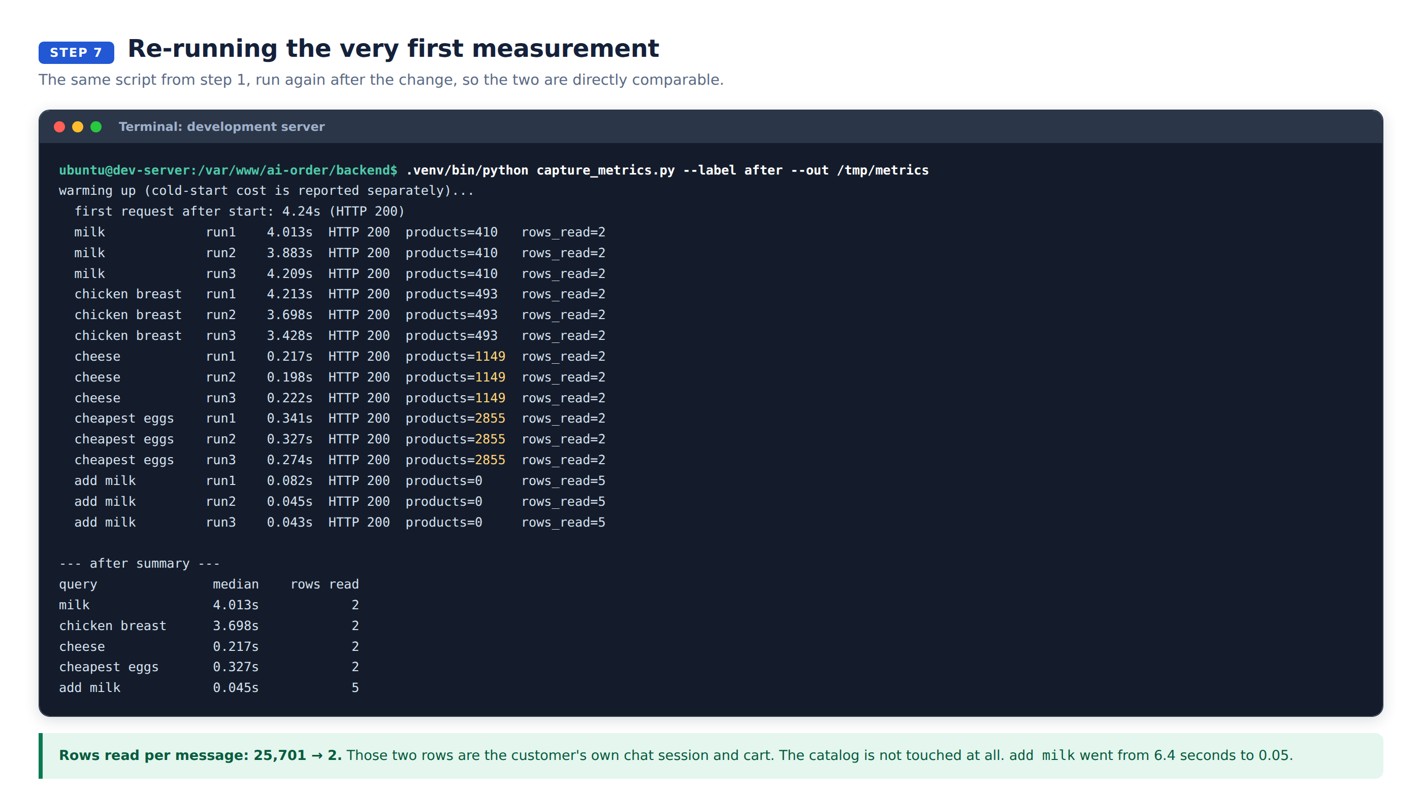
Same script as step 1

Step 8. Automated tests
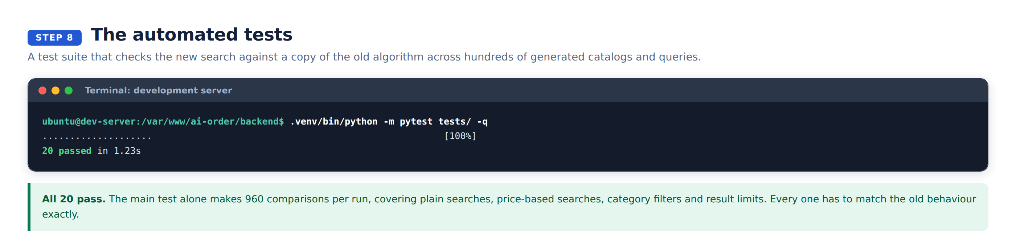
20 tests

Step 9. Switching it off and back on
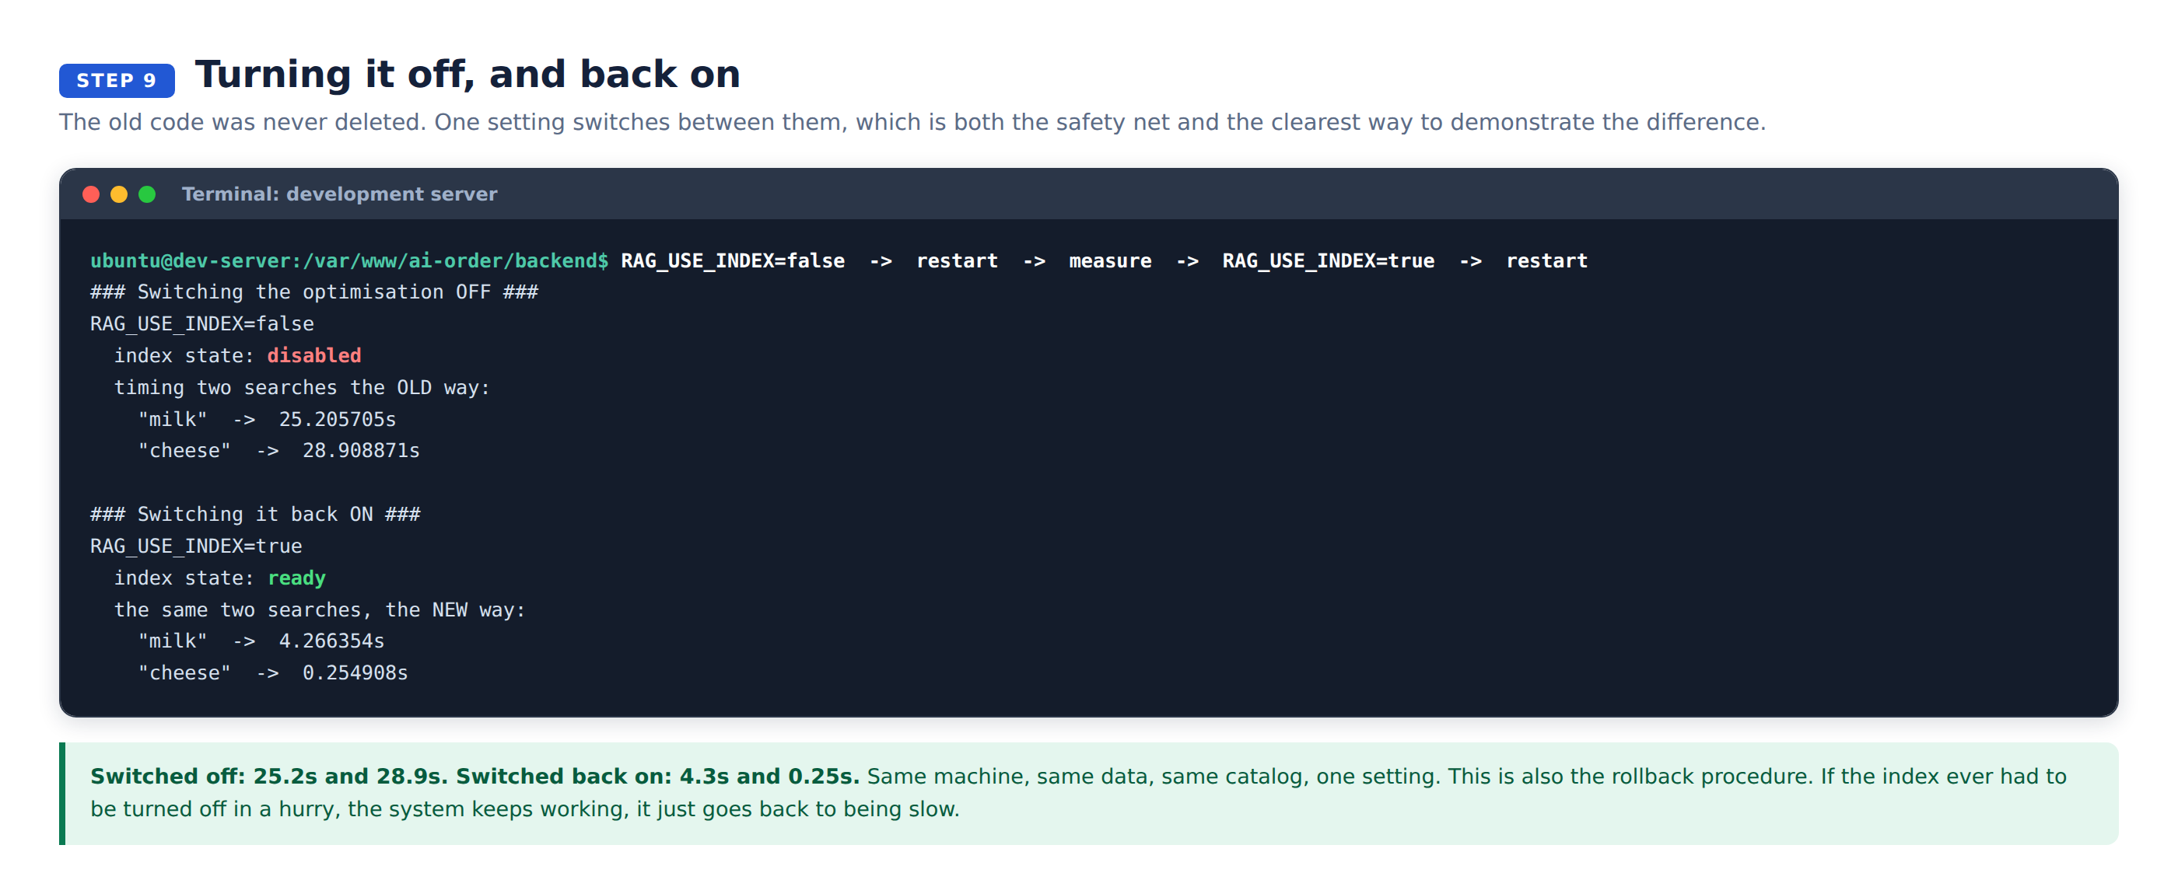
The old speed on demand
The 25 to 29 second figures are higher than step 1 because these were taken straight after a restart, with the database cache cold. That is the state customers hit after an update.

Step 10. Against the live database
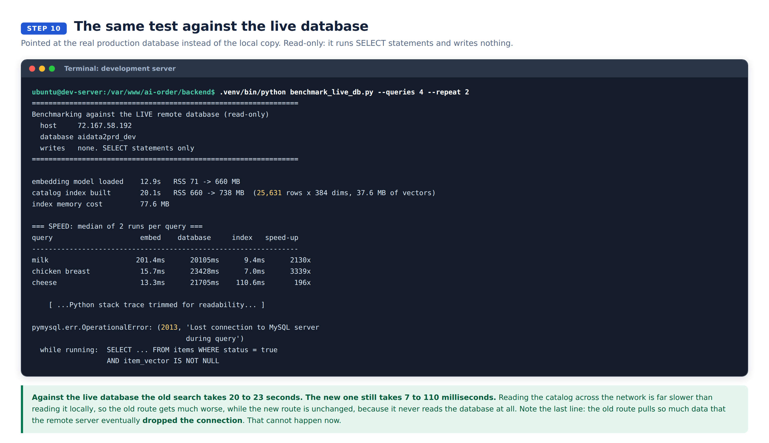
Read-only. SELECT statements only, nothing written

If the .env is switched to the live database
 | What happens
Start-up | 20 seconds longer. The catalog is read across the network once, in the background.
Every search after that | Unchanged. Single-digit milliseconds.
Products, order, prices | Unchanged.

