AI-Order | Conversational Shopping Assistant
Search Speed: Results
Measurements, live database comparison, and acceptance.
Prepared by: Abad Naseer
Project: AI-Order (SmartMarket) conversational shopping assistant
Environment: Development, dev.agent.fordev.fun
Catalog size at time of measurement: 25,631 products

Search speed
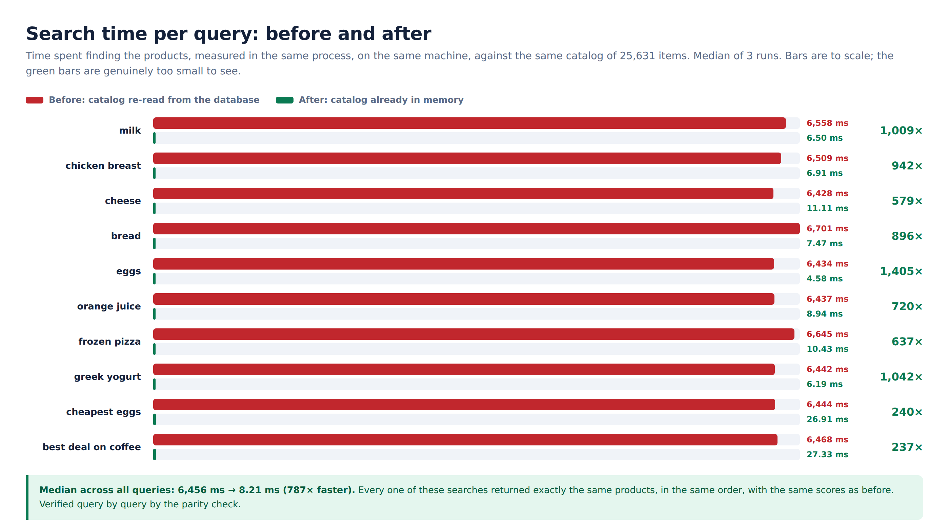
Measured in the same process, same machine, same catalog
Query | Results | Before | After | Faster by
milk | 410 | 6,558 ms | 6.50 ms | 1,009x
chicken breast | 493 | 6,509 ms | 6.91 ms | 942x
cheese | 1,149 | 6,428 ms | 11.11 ms | 579x
bread | 580 | 6,701 ms | 7.47 ms | 896x
eggs | 135 | 6,434 ms | 4.58 ms | 1,405x
orange juice | 809 | 6,437 ms | 8.94 ms | 720x
frozen pizza | 1,056 | 6,645 ms | 10.43 ms | 637x
greek yogurt | 399 | 6,442 ms | 6.19 ms | 1,042x
cheapest eggs | 2,855 | 6,444 ms | 26.91 ms | 240x
best deal on coffee | 2,928 | 6,468 ms | 27.33 ms | 237x
Median |  | 6,456 ms | 8.21 ms | 787x

Live database
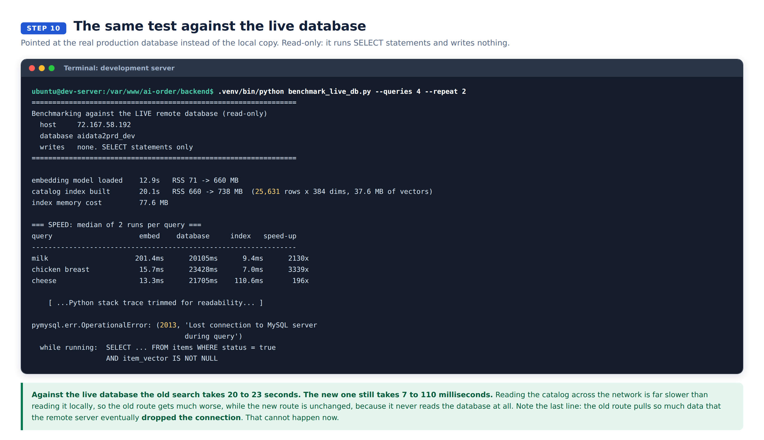
The same benchmark against production, read-only
 | Local copy | Live database
Before | 6,456 ms | 20,105 to 23,428 ms
After | 8.2 ms | 7 to 110 ms
Faster by | 787x | 196x to 3,339x

The old route pulled enough data that the remote server dropped the connection during the test. That cannot happen now.

Whole message, over the API
Message | Before | After | Rows read before | Rows read after
milk | 15.16 s | 4.01 s | 25,701 | 2
chicken breast | 13.65 s | 3.70 s | 25,701 | 2
cheese | 11.38 s | 0.22 s | 25,701 | 2
cheapest eggs | 9.75 s | 0.33 s | 25,701 | 2
add milk | 6.37 s | 0.05 s | 25,704 | 5

The spread in the "after" column is the AI phrasing step, not the search. Search contributed under 30 ms in every case.

Results are identical
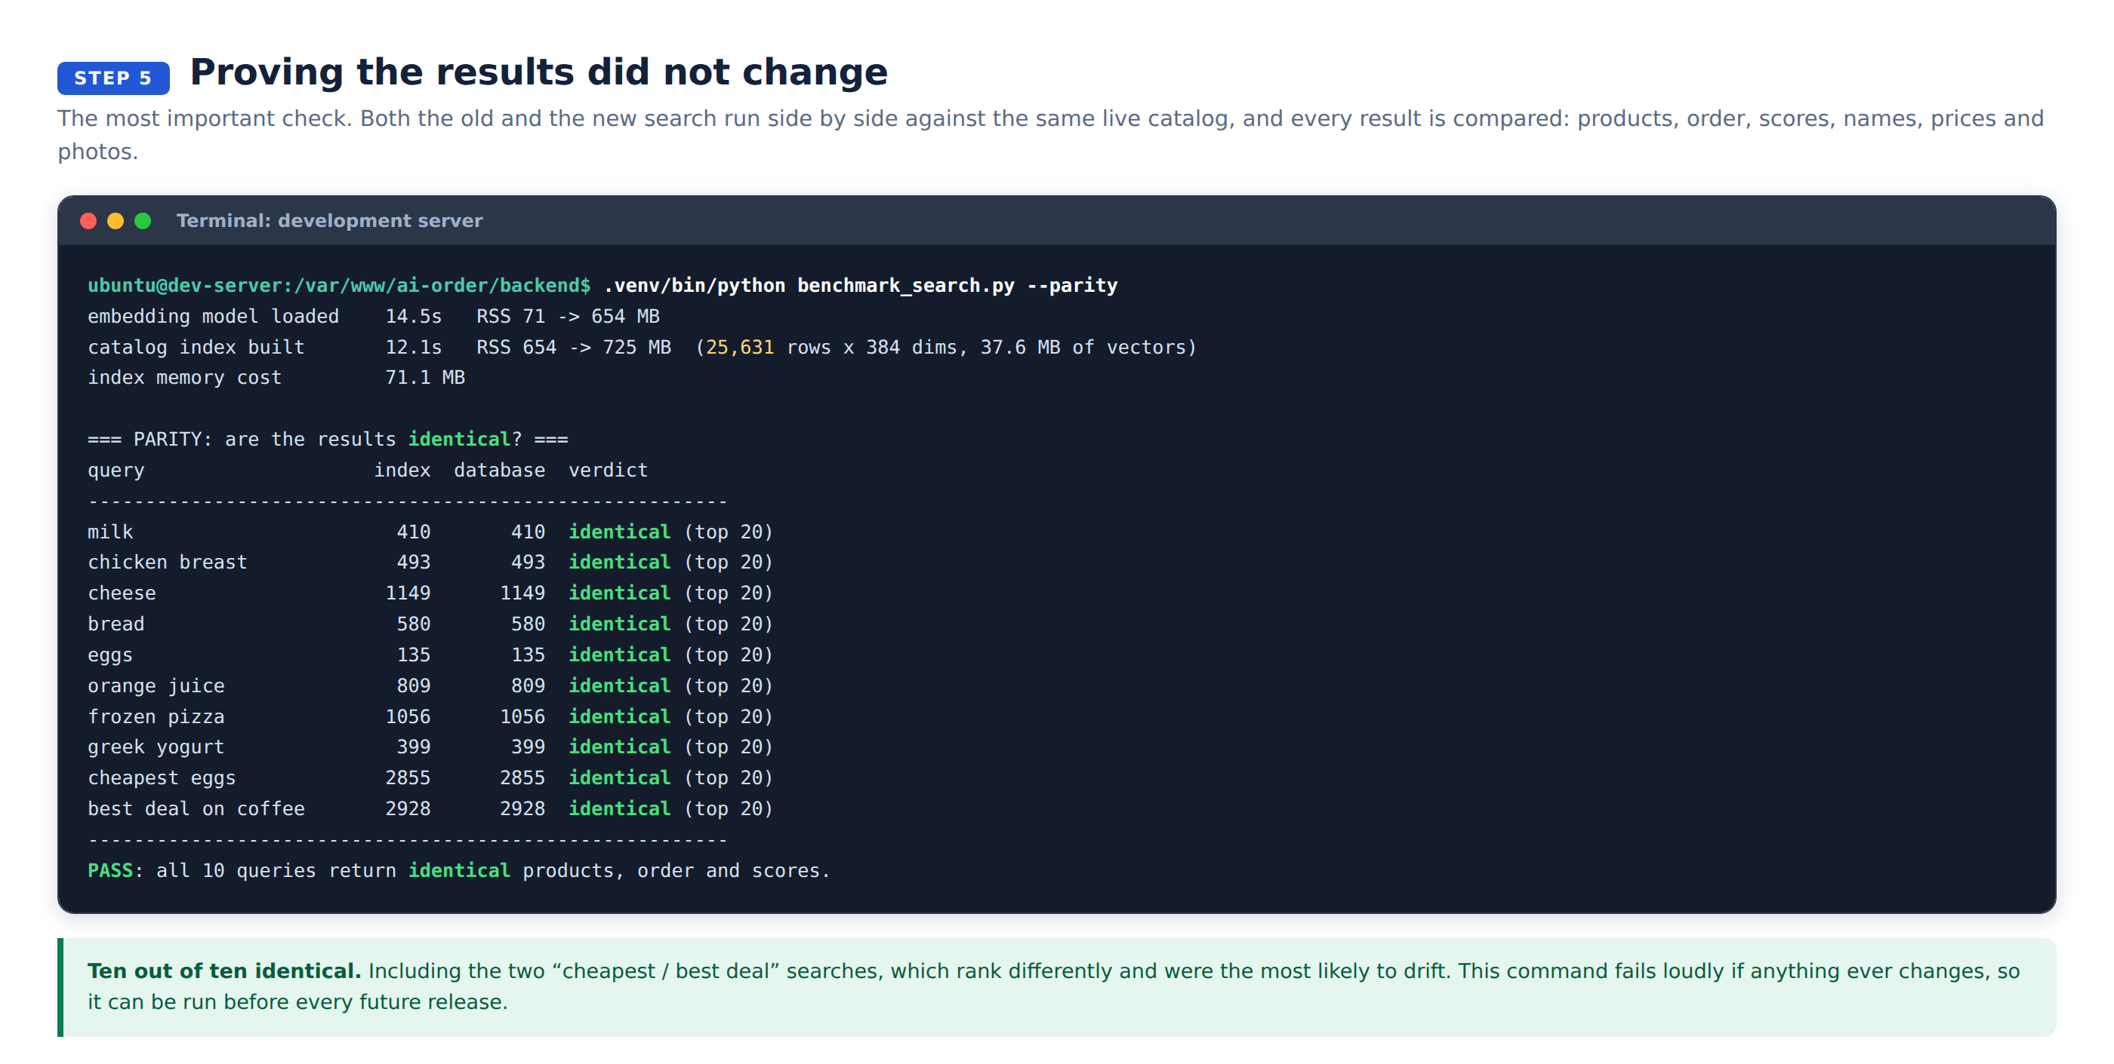
10 of 10 queries verified
Compared: number of results, product order, relevance scores, names, prices, stock, photos and store.

Acceptance
Criterion | Status
Search at least 10x faster | Met. 787x
Same products, order and scores | Met. 10 of 10
No wait for the AI model after a restart | Met
Restarting causes no downtime | Met. Site answers in 0.3 s
Catalog cannot go stale after an import | Met. Rebuild is automatic
Memory acceptable on the current server | Met. 77.5 MB of 1.9 GB
One-step rollback exists | Met. One setting, no redeploy
Chat, cart and checkout unaffected | Met. Re-tested end to end

Check it yourself
What | How
Index status | Open https://dev.agent.fordev.fun/health
Feel the speed | Use the chat at https://dev.agent.fordev.fun/chat
Which route a search took | `sudo journalctl -u aiorder -f \
Prove results are identical | .venv/bin/python benchmark_search.py --parity
Re-measure the speed | .venv/bin/python benchmark_search.py --compare --repeat 3
Test the live database | .venv/bin/python benchmark_live_db.py --queries 4 --repeat 2

Stop the service before running the benchmarks. They load their own copy of the model and catalog, and the development server has 1.9 GB of memory.
Raw data for every number above is in docs/speed-optimization/baseline/ and results/.

