AI-Order | Conversational Shopping Assistant
Search Speed: Technical Reference
For whoever maintains the code next.
Prepared by: Abad Naseer
Project: AI-Order (SmartMarket) conversational shopping assistant
Environment: Development, dev.agent.fordev.fun
Catalog size at time of measurement: 25,631 products

For whoever maintains the code next.

What changed
rag.search_products() used to load all 25,631 products from MySQL on every call. It now scores against a matrix held in memory. The original implementation is kept as _search_products_db() and runs automatically whenever the index is unavailable.
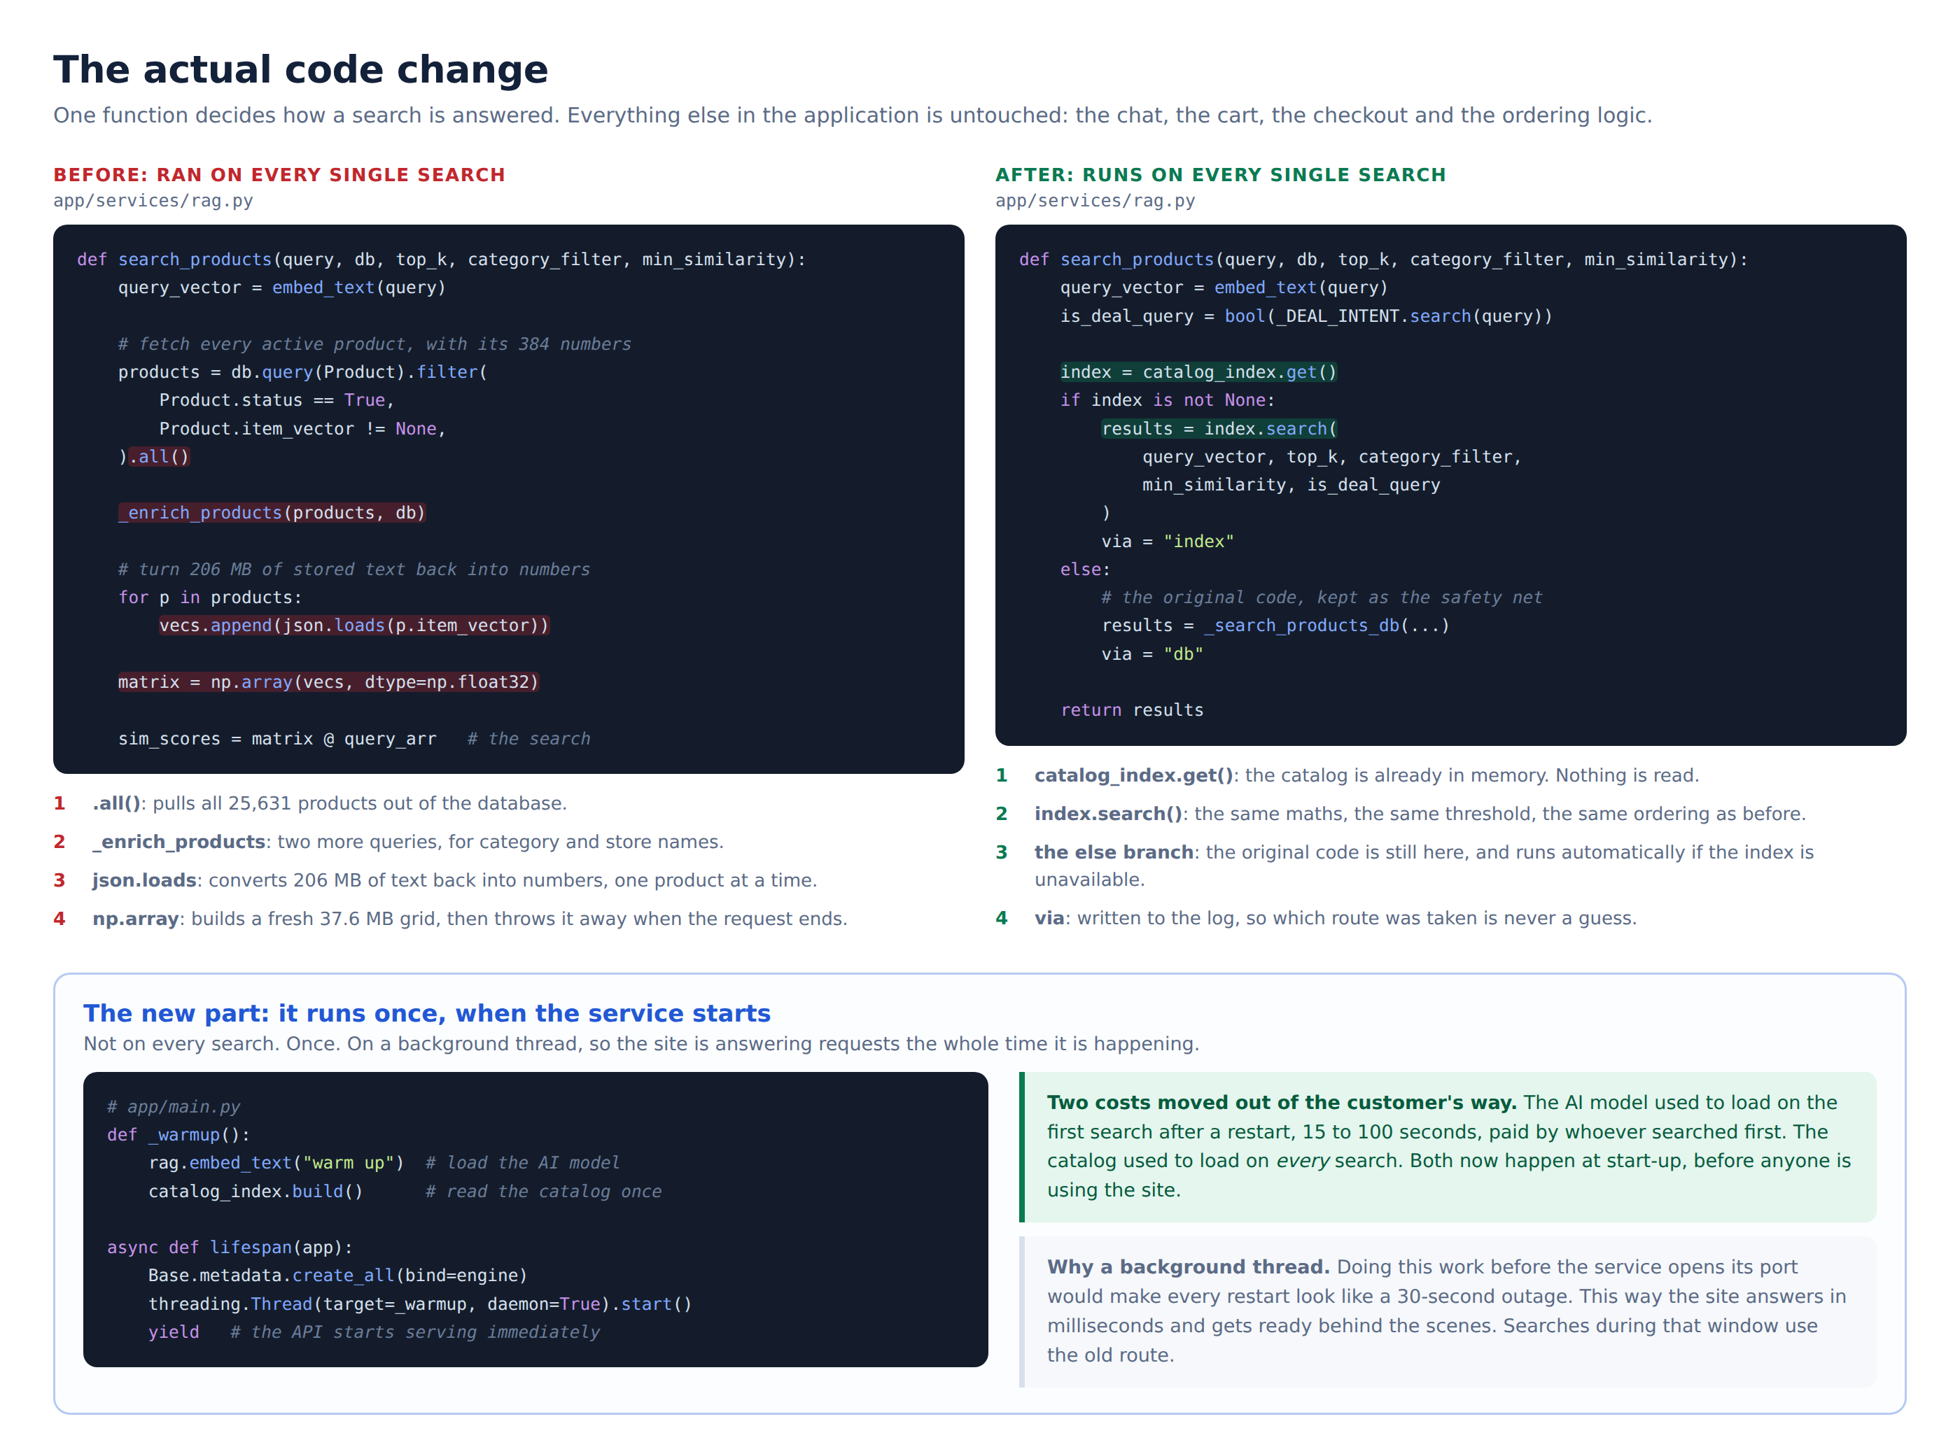
The code, before and after

The index
class CatalogIndex:
matrix: np.ndarray # (25631, 384) float32, C-contiguous, 37.6 MB
meta: list[tuple] # id, name, description, price, stock, image,
# store_id, category_id, category, owner_email
cat_codes: np.ndarray # (25631,) int32
cat_names_lower: list[str]
Metadata is stored as tuples rather than dicts, and category names and store emails are interned. Result dictionaries are built only for rows a query returns.

Build
One streamed query replaces the three the old path ran per request:
SELECT i.id, i.name, i.description, i.price, i.stock, i.image,
i.store_id, i.category_id, c.name AS category_name, s.email AS owner_email,
i.item_vector
FROM items i
LEFT JOIN categories c ON c.id = i.category_id
LEFT JOIN stores s ON s.id = i.store_id
WHERE i.status = 1 AND i.item_vector IS NOT NULL
ORDER BY i.id
Run with stream_results=True in 2,000 row partitions into a pre-allocated np.empty((N, 384), np.float32). Peak memory stays near 37.6 MB instead of holding 206 MB of vector text as Python lists. Raw SQL, no ORM objects.

Search
sims = self.matrix @ q # one matrix-vector multiply
keep = sims >= min_similarity # the same 0.35 threshold
hits = np.flatnonzero(keep)
order = hits[np.argsort(-sims[hits], kind="stable")]
Only surviving rows are sorted. The sort is stable, so ties keep catalog order as Python's list.sort did.

Why results are identical
All 25,631 stored vectors were sampled and confirmed unit length (L2 norm min 1.0000, max 1.0000, std 0.0000). The dot product was already true cosine similarity, so moving the vectors into memory changes no arithmetic.
Each step was reproduced rather than reimplemented:
Step | Preserved
Query normalisation | Redundant re-normalise kept, so query vectors are bit-identical
Threshold | Same >= 0.35, same float32 to float64 promotion
Ordering | Stable descending sort, ties keep catalog order
Missing category | NULL resolves to "General"
Category filter | Same case-insensitive substring test
Deal-intent blend | Same (similarity * 0.6) + (price_score * 0.4) over the same filtered set
Image URLs | Both paths call serialized_image_for()

Checked two ways: tests/test_catalog_index.py runs 960 comparisons per seed against a transcription of the old algorithm, and benchmark_search.py --parity compares both paths against the live catalog.

Configuration
Added to backend/.env. All have defaults, so an old .env still works.
Setting | Default | Purpose
RAG_USE_INDEX | true | Master switch. false reverts to the database path on restart.
WARMUP_ON_STARTUP | true | Load the model and build the index at boot.
ADMIN_TOKEN | (empty) | Guards the admin endpoints. Empty disables them.
INDEX_MAX_ROWS | 200000 | Refuse to build above this rather than exhausting the server.

Generate a token with openssl rand -hex 24.

Memory
Vector matrix | 37.6 MB
Process growth when the index is built | 77.5 MB
Service RSS in steady state | ~770 MB, mostly PyTorch and the embedding model

The service runs as a single uvicorn worker, so there is one copy of the index. Adding --workers N would multiply the memory cost by N.

Operating it
# which route searches are taking
curl -s https://dev.agent.fordev.fun/health | python3 -m json.tool
sudo journalctl -u aiorder -f | grep "via="
# after changing the catalog (rebuild is triggered automatically)
.venv/bin/python import_items_from_remote.py
# rebuild by hand, no restart
curl -X POST https://dev.agent.fordev.fun/api/v1/admin/reindex \
-H "X-Admin-Token: <token from .env>"
# tests
.venv/bin/python -m pytest tests/ -q

Rollback
sudo sed -i 's/^RAG_USE_INDEX=.*/RAG_USE_INDEX=false/' /var/www/ai-order/backend/.env
sudo systemctl restart aiorder
No redeployment, no code change. /health will report "state": "disabled".

Known items, outside this milestone
Item | Detail
Response size | A search returns every match above 0.35, up to 2,928 products, all sent to the browser and written to the session row. The chat shows five. Capping this changes the API contract, so it needs a decision.
GET /api/v1/products | Still scans the whole catalog. It includes products without embeddings, which the index does not hold, so serving it from the index would silently drop rows.
Gemini quota | The dev key is returning HTTP 429. The app falls back to built-in wording, so nothing breaks, but replies are not AI-worded.
Product names | 2,292 of 25,631 names contain a literal ? where an apostrophe belongs. Verified identical in the client's own database, so it arrived with the source data.

